**BSD Manual**

**Band Sample Data Collection**

**Rome Virgo Group**

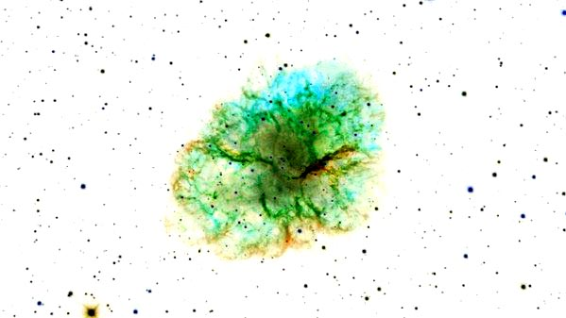

Last upgrade: 2023-05-19

Table of contents

Table of contents 3

Introduction 5

BSD format 7

The **tfstr** structure 9

BSD folder 11

BSD functions 13

BSD creation 13

Service functions 15

**BSD Lego operations** 22

**Sub-table extraction** 24

**Choice of the procedure** 25

**Cut and paste procedures** 26

**BSD EquiLego operations (2021)** 27

BSD basic 28

BSD decoration 31

BSD collection access 35

BSD PSS 37

**Work structures** 37

**Functions** 38

**BSD other searchs** 40

BSD time events 41

**BSD noncohe** 42

**Typically batch procedures and reanalysis** 42

sid_sweep 42

**Typically interactive procedures** 47

sid_sweep_tf 47

sid_sweep_ref 49

sid_sweep_ref_multisband 50

sid_sweep_ref_multidirec 50

sid_sweep_multi 51

bsd_noncohe_full 52

Sidereal pattern analysis 53

Other 55

Service 56

NC procedures 58

**Basic engine** 58

First level analysis 62

Batch functions 64

Service functions 66

Data collection analysis 67

BSD GUIs 87

BSD procedures 88

BSD analysis procedures 91

Non-bsd useful functions 93

Service 93

VFS (Varying Frequency Signal) 95

MC Filter 98

Example scripts 99

Extracting events 99

Extracting narrow bands 102

Correction of Doppler and spin-down 103

Software injections 105

Compute 5-vec 107

equi_example 109

Code Blocks (“BSD snippets”) 111

**General job program** 115

Appendix 116

Debug & check 116

Index 117

Introduction

The **gd** is the basic snag class or an object of this class.

A **bsd** is a type 1 gd that contains complex sampled data with information on the gravitational wave signal in a band.

The bsd have a particular cont structure.

There are basic or “**primary**” bsd that are stored and collected in a particular folder structure, the BSD collection.

Starting from a BSD collection, one can construct other “**secondary**” bsd.

Another document on bsd is the **PSS_UG_III.docx** that describes in more details the use of the bsd for the PSS search.

At 8-Nov-2016:

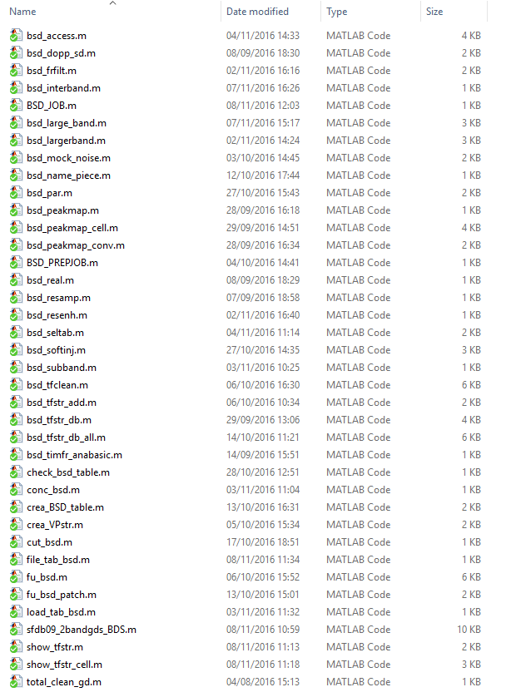

BSD format

A bsd is a standard gd with peculiar **cont** structure (primary bsd):

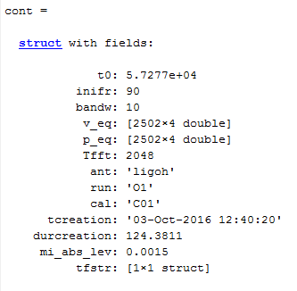

**t0** is the mjd of the first sample (the ini of the gd is 0 and the dx is the sampling time in seconds.

**inifr** is the lower frequency of the band in Hz.

**bandw** is the bandwidth (in Hz)

**v_eq** is the detector velocity components in unit of c, with the time in s since the beginning of data

**p_eq** is the detector position components in a SSB system in unit light seconds, with the time in s since the beginning of data

**Tfft** is the duration of the original SFDB ffts (in practice almost useless)

**ant**, **run** and **cal** are the antenna, run and calibration

**tcreation** and **durcreation** are the creation time and duration

**mi_abs_lev** the standard amplitude computed by logarithmize (the cleaning threshold is at 10*mi_abs_lev)

**tfstr** time-frequency “decoration” structure.

The time-frequency “decoration” structure is:

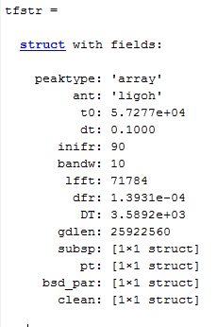

To extract the tfstr, use the function tfstr_gd(*decorated bsd*):

function tfstr=tfstr_gd(gin)

% extracts tfstr structure

% Version 2.0 - September 2016

In secondary bsd can be an **oper** structure that contains information and parameters used to generate it.

If the starting bsd was secondary, the oper structure contains inside the original oper structure. And so on, recursively.

A **full-band bsd** is a particular type of bsd, that has the entire (Nyquist) band. In this case some parameters can be missing. It has the half sampling frequency of the real data.

## The **tfstr** structure

The elements of the structure are:

* **peaktype** array or cell
* **ant,t0,dt,inifr,bandw** as in cont
* **lfft** used fft length (in samples
* **dfr** frequency bin
* **DT** =lfft*dt/2 time between two ffts
* **gdlen**  number of samples in the original gd
* **subsp**  short spectrum
  + **Nsstim**
  + nss
  + lss
  + init
  + typ
  + hdens
  + wn
* **pt**  peak table structure
  + **thr**
  + tpeaks
  + npeaks
  + ntotpeaks
  + peaks
  + ntotpeaks
  + ok
* **bsd_par** bsd parameters
  + **frmax**
  + tfft0
  + lfft0
  + dfr0
  + Ndop
  + sky
    - x
    - b
    - index
    - nlon
    - nskypoint
    - nbeta
    - x2
    - maxbeta
    - minbeta
* **clean** cleaning structure
  + **nt**
  + **nfr**
  + **NF**
  + **NT**
  + **DF**
  + **DT**
  + **PHT**
  + **mpers**
  + **persist**
  + **tfhist**
  + **htfhist**
  + **xhtfhist**
  + perscutfr
  + tfcut
  + **persist0**
  + **tfhist0**
  + **htfhist0**
  + **xhtfhist0**

BSD folder

The BSD folder contains one folder for each run and all the BSD tables.

Any run folder contains a folder for each antenna.

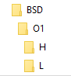

Content of BSD folder:

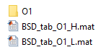

Content of O1 H folder:

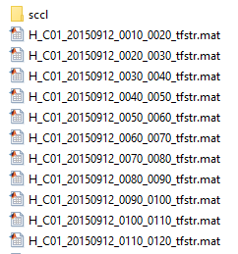

BSD table for O1 Hanford:

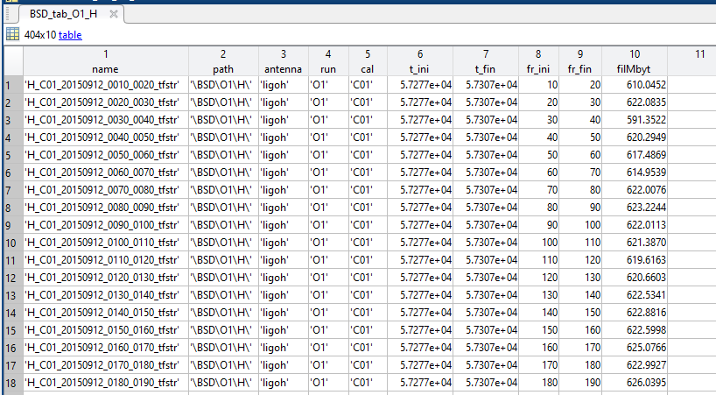

BSD functions

There are many functions operating on BSDs. Here is a list of the most basic. There are also folders with procedures, examples, check&debug, and so on.

There is also a collection of **global variables** used to modify the behavior of some functions:

* bsd_glob_noplot
* bsd_glob_level
* bsd_glob_stack
* bsd_glob_stacklev
* bsd_glob_nozeroing

**Remember to reset (set to 0) global variables at the end of use. The reset_bsd_glob() function may be used.**

BSD creation

function [g, y, itimes, headers]=…

sfdb09_2bandgds_BDS(pialist,foldout,frmin,frmax,BSD_BAND,nfft,run,sim)

%SFDB09_2BANDGDS creates BSD gds

% fseek

% out=sfdb09_2bandgds(pialist,foldout,frmin,frmax)

%

% pialist input file list

% foldout output gds folder

% frmin,frmax operation range (depends on the number of gds to manage simultaneously)

% (for one gd 210 MB are needed)

% calibration sting e.g. 'C00' or 'C01' indicates the calibration version

% sim =1 usa solo la sinusoide

% diverso da 2 e 1 usa i dati veri altrimenti una sinusoide al posto dei dati

% =2 usa dati+sinusoide

% struct, ex.:

% sim.type = 3 implemented in v10

% .VP VP array

% .fr frequency

%

% sim.type = 4 not implemented

% .VP VP array

% .fr central frequency

% .fivev 5-vec

% if window=0 window the data

% HEADER

% piahead.einstein=fread(fid,1,'float32'); %

%

% piahead.detector=fread(fid,1,'int32'); % detector (0,1)

% piahead.tsamplu=fread(fid,1,'double'); % original sampling time

% piahead.typ=fread(fid,1,'int32'); % interlacing (0, 2)

%

% piahead.wink=fread(fid,1,'int32'); % window type

% piahead.nsamples=fread(fid,1,'int32'); % number of samples of fft

% piahead.tbase=fread(fid,1,'double'); % length of fft in s

% piahead.deltanu=fread(fid,1,'double'); % fft frequency bin

% piahead.firstfrind=fread(fid,1,'int32'); % first index (e.g.: 0)

% piahead.frinit=fread(fid,1,'double'); % initial frequency

% piahead.normd=fread(fid,1,'float32'); % factor |fft|^2 -> pow spect

% piahead.normw=fread(fid,1,'float32'); % factor window (to be multiplied for normd)

%

% piahead.red=fread(fid,1,'int32'); % reduction factor (very short spectrum)

%

% !!! NO SQRT(2) CORRECTION FOR SFDB09 CREATED AFTER 15 APRIL 2010

% !!! for sfdb09 files created before, use sfdb09_band2sbl_rad2

% Snag Version 3.0 - April 2016

Service functions

function bsd_glob_set=reset_bsd_glob()

% resets all global variables

%

global bsd_glob_noplot bsd_glob_level

bsd_glob_noplot=0

bsd_glob_level=0

bsd_glob_set.noplot=bsd_glob_noplot;

bsd_glob_set.level=bsd_glob_level;

function gdin=total_clean_gd(gdin)

%

% 1.sel_data_v3 --> selects science segments data using sciseglist

% 2.logarithmize --> evaluates the median abs level to be used in 3. (*10 typical threshold)

% 3.complex_clip --> applies cleaning usign the threshod compute in 2.

% 4.add_zeros_gd_ini --> add zeros at the beginning of the gd, makes the gd

% start at h 0 of the relative day of the first data

%

% gdin gd to be cleanded

% sciseglist science segmennt list (different format of files pay attention) (e.g '/storage/users/piccinni/O1_H1_segments_science_full.txt')

%

%%O.J.Piccinni july 2016

tic

[~,mi]=logarithmize(gdin)

gdin=complex_clip(gdin,10*mi);

% gdin=add_zeros_gd_ini(gdin);

cont=cont_gd(gdin);

cont.tcreation=datestr(now);

cont.durcreation=toc;

cont.mi_abs_lev=mi;

gdin=edit_gd(gdin,'cont',cont);

function [VPstr,contout]=crea_VPstr(ant,timdop,doptabs,ingd)

% vel,pos,einst for some time samples

%

% ant antenna structure or name

% timdop times for doppler data [start (mjd) samp.t (s) n] ! def values for 0

% doptabs doptabs structure (a field each antenna,

% columns are (mjd posx posy posz velx vely velz einst)

% ingd imperfect gd or reuested

%

% VPstr used in interp_VP and other bsd software

% Version 2.0 - October 2016

function name_piece=bsd_name_piece(name,prot)

% decodes bsd name pieces

%

% name_pieces=bsd_name_pieces(name)

%

% Version 2.0 - October 2016

function BSD_tab=crea_BSD_table(list,tabname)

% creates a BSD table from a list of files

%

% list file list with path (ex.: 'list_O1_L_tfstr.txt')

% tabname table name (ex.: 'BSD_O1_L')

% Version 2.0 - October 2016

function [bsd_o,i1,i2]=cut_bsd(bsd_i,tt) **% OPER structure**

% cuts a bsd

%

% bsd_i input bsd

% tt [tin tfi] time interval (mjd or seconds from beginning)

% Version 2.0 - October 2016

function [bsd_o,ini2]=conc_bsd(bsd_i1,bsd_i2)

% concatenates two bsd that should be compatible (same band, same sampling time)

%

% bsd_i1 first input bsd

% bsd_i2 first input bsd

% Version 2.0 - October 2016

function out=check_bsd_table(tab)

% checks a bsd table

% Version 2.0 - October 2016

function tab_out=bsd_seltab(tab,ii,varargin)

% bsd table selection

%

% tab master table

% ii selection indices

% varargin couples of variables (item, values)

% Version 2.0 - November 2016

function files=file_tab_bsd(addr,tab)

% adds path and extention to bsds from a table

%

% files=file_tab_bsd(addr,tab)

%

% addr BSD path (without final dirsep)

% tab bsd table

% Version 2.0 - October 2016

function [bsd, name]=load_tab_bsd(addr,tab,k,modif)

% loads a bsd from a table

%

% [bsd, name]=load_tab_bsd(addr,tab,k)

%

% addr BSD path (without final dirsep)

% tab bsd table

% k file index

% modif modification structure

% Snag Version 2.0 - October 2016

function tab_out=bsd_extr_subtab(tab, tim,fr)

% extracts a sub table from a bsd table

%

% tab input table

% tim any time in the file (0 no choice)

% fr any frequency in the file (0 no choice)

% Snag Version 2.0 - May 2017

function par=bsd_par(in,parin) %% CHECK !!

% parameters for BSDs

%

% in input bsd

% parin (if present) input parameter structure

% Version 2.0 - September 2016

function out=bsd_subband(in,band,st)  **% OPER structure**

% extract band (output signal is complex)

% [similar to extr_band]

%

% out=bsd_subband(in,band,st)

%

% in input gd (type 1)

% band [min max] frequency (aliased)

% st sampling time (if present; otherwise st=1/band)

%

% ATTENTION ! the samples start since the 0 hour of the first day of the run

% so, the first sample of the file can be advanced: in this

% case the first sample is a 0

% Version 2.0 - September 2016

function [out,st,band,pars]=bsd_reshape(in,tab,bandin,t00)

% reshapes a bsd in order to concatenate sub-bands

% corrects starting sample and starting frequency and length

%

% [out,band]=bsd_reshape(in,bandin,t00)

%

% in input bsd

% tab table of the bsds to be concatenated

% bandin requested band [frin frfin]

% t00 requested basic time (optional - def 0 hour of run starting day)

%

% out reshaped bsd

% dfr frequency quantum

% band true band

% Snag Version 2.0 - November 2016

function [bsd_sb,pars]=bsd_concsubband(addr,BSD_tab_out,bandin,modif)

% sub-band of concatenated bsds

%

% [bsd_sb,pars]=bsd_concsubband(addr,BSD_tab_out,bandin,modif)

%

% addr path that contains BSD data master directory without the final dirsep

% BSD_tab_out operative file table

% bandin requested band

% modif modif structure (or cell array) for bsd_acc_modif

% Snag Version 2.0 - November 2016

function [zhole, holes, dholes, thole]=bsd_holes(in)

% identifies holes in a bsd

%

% in input bsd

%

% holes a vector with odd elements index of starting data and even elements index of starting hole

% thole (n 2) start and stop mjd of holes

% Snag Version 2.0 - November 2016

function out=bsd_zerointerv(in,zint)

% zeroes intervals (as holes...) of a bds

%

% out=bsd_zerointerv(in,zint)

%

% in input bsd

% zint (n,2) couple of indices (start stop)

% Snag Version 2.0 - November 2016

function out=bsd_zeroholes(in1,in2)

% forces to zero the holes

%

% in1 bsd to be zeroed

% in2 bsd with the holes

% Snag Version 2.0 - November 2016

function out=bsd_dayplot(bsd,typ)

% plots a bsd with better abscissa

%

% out=bsd_dayplot(bsd,typ)

%

% bsd input bsd

% typ type of abscissa start:

% 1 day (default)

% 2 week

% 3 month

% 4 year

% Snag Version 2.0 - January 2017

function yn=is_bsd(in)

% type of bsd

%

% yn=is_bsd(in)

%

% in gd

%

% yn = 0 no, simple gd

% = 1 basic bsd

% = 2 complete primary

% = 3 complete secondary

% = 4 complete oper present

% = 5 complete decorated

% Snag Version 2.0 - January 2017

function [inifr,bandw,dt,iok]=bsd_orthoband(inifrs,bandws,dt0)

% computes the smallest "fine" band for bsds

%

% inifrs,bandws signal band

% Snag Version 2.0 - February 2017

function lines=ligo_readlines(fil)

% reads lines ligo files (in csv format)

%

% fil lines Ligo file (in csv format)

%

% typical file: O2H1lines.csv

% Column 1 - frequency spacing (Hz) of comb (or frequency of single line)

% Column 2 - comb type (0 - singlet, 1 - comb with fixed width, 2 - comb with scaling width)

% Column 3 - frequency offset of 1st visible harmonic (Hz)

% Column 4 - index of first visible harmonic

% Column 5 - index of last visible harmonic

% Column 6 - width of left band (Hz)

% Column 7 - width of right band (Hz)

%

% For fixed-width combs, veto the band:

% [offset+index*spacing-leftwidth, offset+index*spacing+rightwidth]

% For scaling-width combs, veto the band:

% [offset+index*spacing-index*leftwidth, offset+index*spacing+index*rightwidth]

% Snag Version 2.0 - November 2018

function pulsar=read_pulsar_Ligo_file(plist,kpuls,gpsref)

% Creates a cw source structure from Ligo list

%

% plist file name (csv type)

% kpuls number of the pulsar

% gpsref gps reference time (default from the name of the csv file)

% Snag Version 2.0 - November 2018

## **BSD Lego operations**

Here the basic composition rules and procedures for cut and paste BSDs are described. These are the basic operations:

**Time operation:**

1. interval extraction
2. appending periods

**Frequency operation:**

1. sub-band extraction
2. more bands synthesis

Often an **A** operation is connected with a **D** operation and can be performed in “large band” way (the starting frequency is the lowest frequency) and “larger band” way (the starting frequency is 0 and the original frequencies are reconstructed).

A **C** operation is often connected with a **B** operation.

A particular type of sub-band is an **ortho-band**. The full band of a BSD is the band



with Δt the sampling time. An ortho-band has a width with k integer and is limited by the frequencies (j-1)·B and j·B. Therefore, an ortho-band is defined by two integer number, j and k. The sampling time associated to an ortho-band is .

To guarantee the correct connection of data from different periods in a sub-band, it is important that:

* all the sub-bands for the different pieces are absolutely equal
* the sampling time of the

There are many ways to cut and paste BSDs. The basic problems are

* avoid discontinuities
* avoid artifacts
* operate with the least memory
* be fast
* be simple for users
* be simple for programmers

**To operate in the best way the ortho-band should have a number of bins that is a submultiple of the length of the fft used for the cut and paste operation. With this choice, the new sampling time is a multiple of the original sampling time.**

The cut-and-pasted data form a new bsd.

The procedure to build the new BSD is **bsd_lego** (former bsd_access). It is composed of 3 parts:

1. extract the sub-table of the necessary BSDs
2. define the procedure to use
3. apply the procedure

### **Sub-table extraction**

### **Choice of the procedure**

### **Cut and paste procedures**

## **BSD EquiLego operations (2021)**

A better way to concatenate BSDs for short bands is performed by the EquiLego procedures. With these procedures there is no limitation to ortho-bands: any band, contained inside one or two adjacent basic band can be extracted.

function [bsd_out,BSD_tab_out,stpar]=bsd_equilego(addr,tab,tim,freq,modif,modifpost)

% data access alternative to bsd_lego

% good for any subband and more months

%

% limits:

% no modes (there are two automatic modes)

% out band could be any, but should be inside 2 adjacent basic BANDs

%

% [bsd_out,BSD_tab_out,stpar]=bsd_equilego(addr,tab,tim,freq,modif,modifpost)

%

% addr path that contains BSD data master directory without the final dirsep

% or structure with all the input parameters as fields

% tab BSD table (charged)

% tim [tini tfin] (mjd) ; if length(tim) = 1 or tini=tfin the whole run

% [tini tfin dt0] if the sampling time dt0 of the BSD collection is not 0.1 s

% freq [frini frfin] ; if length(freq) = 1 or frini=frfin the full band with frini (def ortho-band)

% (freq is the requested band, band will contain the effective band)

% modif (if present) modification structure: modifies accessed primary files

% e.g. adding signals or sources; see bsd_acc_modif

% [] no modification

% modifpost (if present) modification after the band extraction

Example:

[bsd_out,BSD_tab_out,stpar]=bsd_equilego('K:',BSD_O3_H,0,[108 109])

[bsd_out,BSD_tab_out,stpar]=bsd_equilego('K:',BSD_O3_H,0,[109 111])

uses

bsd_out=bsd_interband_equilego(addr,tab,stpar,modif)

## **base_orthobands**

function out=base_orthobands(bandin,dt)

% basic orthobands info

%

% bandin requested band

% dt sampling time

%

% base orthobands

% k

% dk 1 2 3 4 5 6 7 8 9...

% 0 * * * * * * * * * * * *

% 1 *

% 2 * *

% 3 * *

% 4 * * *

% 5 * *

% 6 * * * *

% 7 * *

% 8 * * * *

% 9 * * *

% 10 * * * *

% 11 * *

% 12 * * * * * *

%

% OBpar 1 bw, band width, in basic units (1,2,3,...)

% 2 bs, band start, in bw units (0,1,2,...)

% 3 sbd, sub-band divisor (1,2,3,...)

% 4 sbk, sub-band k (1,...,sbd)

%

% red = sbd/bw

% dtout = dt*red

BSD basic

function out=bsd_real(in)  **% OPER structure**

% conversion to real (doubling sampling frequency)

%

% out=bsd_real(in)

% Snag Version 2.0 - September 2016

function out=bsd_freqshift(in,dfr,tref)

% frequency shift for bsd. Shift is circular.

%

% in input bsd

% dfr frequency shift

% tref reference time (def 14 sep 2015)

% Snag Version 2.0 - April 2021

function out=bsd_enlarge(in,enl)

% enlarge frequency domain

%

% in input bsd

% enl frequency domain enlargement (def 2)

% Snag Version 2.0 - April 2021

function out=bsd_dopp_sd(in,sour,sdpar) **% OPER structure**

% Doppler and spin-down correction

%

% out=bsd_dopp_sd(in,sour,sdpar)

%

% in input bsd

% sour source structure

% sdpar spin-down parameters, if different from source

% [df ddf] or df; if sd=0, no spin-down correction

% if absent, uses sour parameters

% Version 2.0 - September 2016

function gout=bsd_mock_noise(gin,kfact,nonst) **% OPER structure**

% bsd mock noise

%

% gin input bsd (to simulate)

% kfact reduction factor (integer)

% nonst (if present) non-stationary mask (with holes)

% Version 2.0 - September 2016

function tfstr=bsd_tfclean(tfstr,anabasic)

% time-frequency cleaning

%

% tfstr=bsd_tfclean(tfstr,anabasic)

%

% - tf filter

% - persistence

% - noise adaptive filter

%

% tfstr tf structure as created by bsd_peakmap

% anabasic procedure control structure

% .pers_thr persistence threshold (0 -> no threshold; typical 0.3)

% .tfh_df time-frequency histogram df

% .tfh_dt time-frequency histogram dt (days) def 0.5

% .tfh_pht time-frequency histogram time phase (hours) def 8 local time

% .tfh_thr time_frequency threshold (0 -> no threshold)

% .noplot = 0 plot (default)

% Version 2.0 - September 2016

function [sbsd,fr,sig0]=bsd_softinj(gin,sour,phs,A) **% OPER structure**

% bsd software injection

%

% sbsd=bsd_softinj(gin,sour,phs,A)

%

% gin input bsd (or bsd data structure)

% sour source

% phs input phases in degrees (ph0, phbin, sidph, phase epoch) [4 components]

% A amplitude (if not present, use sour h)

% Version 2.0 - October 2016

function out=bsd_largerband(list,tin,tfi,addr,outdt)

% synthetic signal from more BDSs

%

% out=bsd_largerband(list,tin,tfi,outdt)

%

% list bsd table or file with bds files list (NO SPACES)

% (if a row of the list begins with *, it is not considered)

% tin initial time (mjd)

% tfi final time

% addr (used in case of table) path without dirsep; otherwise ''

% outdt (if present) output file sampling time

% Version 2.0 - September 2016

function out=bsd_resamp(in)

BSD decoration

The “decoration” of a BSD is the addition of more time-frequency information. This data are grouped in the tfstr structure added to the cont structure (see in the BSD format section)

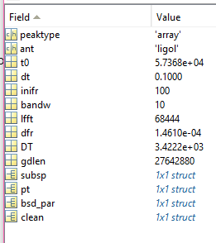

It is created by

function out=bsd_tfstr_add(list,anabasic)

% adds tf structure to bsds

%

% list bsds file list (file should end with sccl)

% anabasic basic analysis structure (if absent, default is used)

% Version 2.0 - September 2016

or, if notch filter is applied,

function out=bsd_tfstr_addwithnotch(list,parnotch,anabasic)

% adds tf structure to bsds performing notch filtering

%

% list bsds file list (file should end with sccl)

% parnotch notch parameters (if absent or a void structure or not a structure, default values)

% .thr threshold on persistence

% .win window (def 1)

% .linel line list [n,2] (frmin frmax)

% anabasic basic analysis structure (if absent, default is used)

% Version 2.0 -November 2018

that uses

function out=bsd_notch(in,parnotch)

% notches on bsds

%

% out=bsd_notch(in,parnotch)

%

% in input bsd

% parnotch notch parameters (if absent or a void structure or not a structure, default values)

% .thr threshold on persistence

% .win window (def 1)

% .linel line list [n,2] (frmin frmax)

% Snag Version 2.0 - November 2018

**2019 Addition: holes info**

The function **bsd_tfstr_add** adds also holes info.

The function

function out=add_zeros2tfstr(in,addr)

% adds zeros info to tfstr

% start from a non-BSD directory

%

% in input bsd or table

% addr address of the table (in the case of table, e.g. 'I:')

%

% out output bsd or number of saved bsd

Adds the holes info on pre-existing bsd files.

The holes info is in a two column arrays with the beginning and end time of holes, in seconds from the beginning.

Here is a list of the function used to create and analyze the tfstr data.

function [tfstr,out]=bsd_timfr_anabasic(in,anabasic)

% basic time-frequency analysis for bsd files

%

% [tfstr,out]=bsd_timfr_anabasic(in,anabasic)

%

% in input bsd

% anabasic analysis control structure

% .thr spectral peak threshold (default 2.5)

%

% tfstr analysis output structure

% out (if present) t-f enriched bsd

% Version 2.0 - September 2016

function out=show_tfstr(in)

% shows features of a tfstr

%

% in bsd gd or tfstr

% Version 2.0 - September 2016

function out=show_tfstr_cell(in)

% shows features of a tfstr

%

% in bsd gd or tfstr

% Version 2.0 - September 2016

function tfstr=bsd_peakmap(in,lfft,thr,typ)

% peakmap creation

%

% tfstr=bsd_peakmap(in,lfft,thr,typ)

%

% in input bsd

% lfft length of the ffts (multiple of 4)

% thr normalized threshold

% typ type structure

% Version 2.0 - September 2016

function tfstr=bsd_peakmap_cell(in,lfft,thr,typ)

% peakmap creation

%

% tfstr=bsd_peakmap(in,lfft,thr,typ)

%

% in input bsd

% lfft length of the ffts (multiple of 4)

% thr normalized threshold

% typ type structure

% Version 2.0 - September 2016

function peaks=bsd_peakmap_conv(tfstrcell)

% converts cell structured peaks to array

%

% Version 2.0 - September 2016

function out=bsd_tfstr_db(list,what,par)

% access bsd db for synthetic results on tfstr

%

% out=bsd_tfstr_db(list,what,par)

%

% list file list with path

% what items

% 'basic' basic parameters

% 'hdens' t-f h densities

% 'wn' wiener filters

% 'peaks' peak table data

% 'skyp' skypoints parameters

% 'pers' persistence

% 'tfhist' t-f histograms

% par parameter structure

% tim [min max] times

% fr [min max] frequencies

% Version 2.0 - September 2016

function out=bsd_tfstr_db_all(list,filout)

% access bsd db for synthetic results on tfstr

%

% out=bsd_tfstr_db(list,what,par)

%

% list file list with path

% filout file to save the structure

% Version 2.0 - September 2016

function out=bsd_tfstr_extr(addr,tab,datyp)

% extracts data from tfstr

%

% out=bsd_tfstr_extr(addr,tabl,datyp)

%

% addr BSD path(without final dirsep, ex.: 'I:')

% tab BSD sub-table (to create a BSD sub-table use

% [tab_out,epoch0,maxt]=bsd_extr_subtab(tab,tim,fr)

% datyp data type ('hdens' 'wn' 'peaks' 'npeaks' 'persist' 'persist0'

% 'tfhist' 'tfhist0')

BSD collection access

function [bsd_out,BSD_tab_out,out]=bsd_access(addr,ant,runame,tim,freq,mode,modif,modifpost)

% data access

%

% [bsd_out,BSD_tab_out,out]==bsd_access(addr,ant,run,tim,freq,mode,modif)

%

% addr path that contains BSD data master directory without the final dirsep

% ant antenna name

% runame run name

% tim [tini tfin] (mjd) ; if length(tim) = 1 the whole run

% freq [frini frfin] ; if length(freq) = 1 the full band with frini

% mode mode = 0 only the output table

% > 0 creates the output bsd

% = 1 automatic

% = 2 sub-band, concatenates files

% = 3 sub-period, many bands

% = 4 inter-bands sub-band

% modif (if present) modification structure: modifies accessed primary files

% e.g. adding signals or sources; see bsd_acc_modif

% [] no modification

% modifpost (if present) modification after the band extraction

% Snag Version 2.0 - October 2016

function [bsd_out,BSD_str_out,out]=bsd_access_str(addr,ant,run,tim,freq,mode,modif)

% data access (STRUCTURE VERSION for old Matlab)

%

% bsd_out=bsd_access_str(addr,ant,run,tim,freq,mode,modif)

%

% addr path that contains BSD data master directory without the final dirsep

% ant antenna name

% run run name

% tim [tini tfin] (mjd) ; if length(tim) = 1 the whole run

% freq [frini frfin] ; if length(freq) = 1 the full band with frini

% mode mode = 0 only the output table

% > 0 creates the output bsd

% = 1 automatic

% = 2 sub-band, concatenates files

% = 3 sub-period, many bands

% = 4 inter-bands sub-band

% modif (if present) modification structure: modifies accessed primary files

% e.g. adding signals or sources; see bsd_acc_modif

% Version 2.0 - November 2016

function out=bsd_acc_modif(in,modstr)

% modifies accessed bsd

%

% out=bsd_acc_modif(in,modstr)

%

% in input bsd (typically same as out)

% modstr modification structure or a cell array with more than one mod. struct

% .typ 'sinsig' 'source' 'tsig' 'schirp'

% typ 'sinsig' sinusoidal signal

% .t00 .fr .ph .amp

% typ 'source' periodic source

% .sour the source structure, .phs .A

% typ 'tsig' time signal (same in some bands)

% .t00 .shape .bands

% typ 'schirp' super-chirp (fr should grow very slowly)

% .t00 .fr0 .dfr .amp

% typ 'secs' super-chirp (fr should grow very slowly)

% .t00

% Snag Version 2.0 - November 2016

function out=bsd_large_band(tab,tin,tfi,addr,outdt)

% reduced bsd_largerband

%

% out=bsd_large_band(tab,tin,tfi,outdt)

%

% tab bsd table

% tin initial time (mjd)

% tfi final time

% addr (used in case of table) path without dirsep; otherwise ''

% outdt (if present) output file sampling time

% Version 2.0 - November 2016

function out=bsd_interband(addr,tab,band,tim)

% inter-band reconstruction

% Version 2.0 - November 2016

BSD PSS

Here are the procedures for production software. There are some different types of procedures:

* blind search
* direct search
* targeted search

Each procedure can be divided in parallel jobs.

### **Work structures**

There are two info structure that control the procedures and the results: the proc_info with the general information on the procedure and the job_info with the info and results on the single job.

proc_info

.bsdcont

.type ‘blind’ ‘direct’ ‘targeted’ ‘follow-up’

.comp ‘normal’ ‘mex’ ‘parallel’

.epoch

.mode

.hm

.oper ‘adaptive’ ‘noadapt’ ‘noiseadapt’ ‘onlysigadapt’

.fr

.dnat

.enh

.sd

.min

.step

.max

.cand

.ref

.fu

.

job_info

.proc

.proc_info

### **Functions**

function [bsd_pack_0, bsd_packs]=BSD_PREPJOB(list,frmin,runstr,mode)

function [cand,bsd_summary,check]=BSD_JOB(bsd_pack_0,bsd_pack,outdir)

function out=bsd_mode(typ)

% model of mode function

%

% typ type number

% Snag Version 2.0 - January 2017

function [hmap,job_info,checkE]=bsd_hough(typ,peaks,proc_info,job_info)

% hough map creation

%

% typ(2) 1-> 1 allsky normal, 2 refinement, 3 follow-up or directed

% 2-> 1 normal, 2 mex file, 3 parallel

% peaks(5+,n) peak table (rows with ...)

% proc_info epoch

% hm.oper ('adapt','noadapt','noiseadapt','onlysigadapt')

% hm.fr (minfr dnat frenh maxfr)

% hm.sd (minsd step nsteps)

% hm.fr (minfr dnat frenh maxfr)

% Adimref=[nsd,nf] if present (refinement)

% job_info used for output

%

% coreHoughDynLoop_mex(peaks,inifr,dfr,Day_inSeconds,deltaf2,ii0,ii,nbin_d,d,I500,nTimeSteps,nf);

% Snag Version 2.0 - January 2017

function [cand,job_info,checkF]=bsd_cand(hmap,proc_info,job_info,kcand)

% finds peaks in the hough map

%

% [cand,job_info,checkF]=bsd_cand(hmap,proc_info,job_info,kcand)

%

% hmap hough map

% proc_info

% job_info

% kcand number of primary candidates to be found

%

% cand(9,N) [fr lam bet sd amp CR dlam dbet typ]

% job_info job info structure

% checkF service structure for test and debug

% Snag Version 2.0 - January 2017

function out=bsd_fu(in,direct,fupars)

% bsd base follow-up

%

% out=bsd_fu(in,direct,lenini)

%

% in input bsd (not corrected, possibly small band)

% direct candidate or direct parameters

% .a right ascenson (deg)

% .d declination

% .f frequency and derivative

% fupars follow-up parameters

% .da RA step

% .dd dec step

% .df frequency and derivatives steps

% .na RA number of steps

% .nd dec number of steps

% .nf frequency and derivatives number of steps

% Snag Version 2.0 - January 2017

function out=dopp_corr_residual(direc,T,icplot,ant)

% residuals after doppler correction

%

% out=dopp_corr_residual(direc,T)

%

% direc direction ([lam bet] or direct structure) or candidate

% T [min max] mjd or bsd

% icplot 1 plot (def 0)

% ant (if T is not a bsd) ant structure

% Snag Version 2.0 - January 2017

## **BSD other searches**

function [tfstr,job_summary,check]=DIRECT_JOB(direct,bsdin,job_direct_0,job_direct,outdir)

%

% proc_info epoch

% fr.dnat

% mode.hm_job.frenh

% hm.oper ('adapt','noadapt','noiseadapt','onlysigadapt')

% **mimaf0

% hm.sd (minsd step nsteps)

% hm.fr if exists (minfr dnat frenh maxfr)

% Adimref=[nsd,nf] if present (refinement)

% Snag Version 2.0 - January 2017

BSD time events

function [ffrbsd,fil]=bsd_frfilt(in,frfilt)

% frequency filter for a bsd gd produced by bsd_largerband

%

% ffrbsd=bsd_frfilt(in,frfilt)

%

% in input bsd

% frfilt frequency filter or 'white' or 'wiener'

% Version 2.0 - November 2016

function hbsd=bsd_resenh(in,enh) **% OPER structure**

% bsd resolution enhancement

%

% in input bsd

% enh (>1) resolution enhancement

% Version 2.0 - November 2016

# **BSD noncohe**

The non-coherent analysis methods are collected in the noncohe folder.

## **Typically batch procedures and reanalysis**

### sid_sweep

function sids=sid_sweep(addr,ant,runame,freq,direc,wband,sband,icflat,frbase,pcheck)

% analyze data from known direction for sidereal patterns

%

% sids=sid_sweep(addr,ant,runame,freq,direc,wband,sband,icflat,frbase)

%

% addr,ant,runame as for bsd_lego

% freq a frequency inside the bsd base band (10 Hz)

% direc direction structure

% wband sub-band division (0.5,1,2,5,10 Hz; typically 1 Hz)

% sband search band (in units of 1/SD; typically 10)

% icflat >0 flat weights (def 0)

% frbase basic bsd frequency (def 10)

% pcheck if present, substitute SD for check (no SOL)

produces

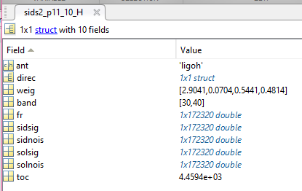

% driver_sid_sweep

bw=10; % bw narrow bandwidth in units of 1/SD (typically 10)

freq=10;

for i = 1:70

nameL=sprintf('sidsGC_%04d_%04d_%d_L',freq,freq+10,bw)

tic

sidsGCL=sid_sweep('I:','ligol','O2',freq+5,GC,1,10)

save(nameL,'sidsGCL')

toc

nameH=sprintf('sidsGC_%04d_%04d_%d_H',freq,freq+10,bw)

tic

sidsGCH=sid_sweep('I:','ligoh','O2',freq+5,GC,1,10)

save(nameH,'sidsGCH')

toc

freq=freq+10;

end

Creates files:

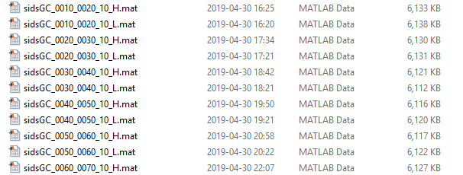

% driver_sid_sweep1

kpuls=[0 1 2 3 5 6 8 9 10 11];

epochO2=57870;

bw=10; % bw narrow bandwidth in units of 1/SD (typically 10)

for ipul = kpuls

puls=['pulsar_' num2str(ipul)];

sidsL=['sids2_p' num2str(ipul) '_' num2str(bw) '_L'];

sidsH=['sids2_p' num2str(ipul) '_' num2str(bw) '_H'];

eval([puls '=new_posfr(' puls ',epochO2);']);

eval(['pfr0=' puls '.f0;'])

eval([sidsL '=sid_sweep(''I:'',''ligol'',''O2'',' num2str(pfr0) ',' puls ',1,10)'])

eval(['save(''' sidsL ''',''' sidsL ''');'])

eval([sidsH '=sid_sweep(''I:'',''ligoh'',''O2'',' num2str(pfr0) ',' puls ',1,10)'])

eval(['save(''' sidsH ''',''' sidsH ''');'])

end

Creates ­­­­­­­­­­­­­­­­­­­­­­­­­­­­­­­­files :

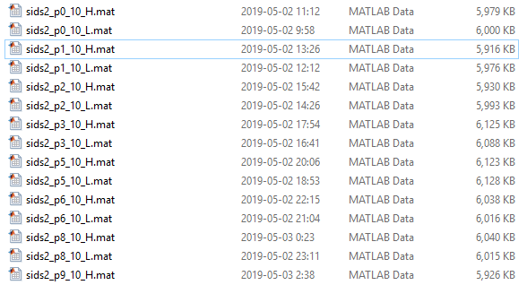

function out=ana_sid_sweep1(ipul,bw)

%

% ipul hardware injection number

% bw narrow bandwidth in units of 1/SD (typically 10)

function out=ana_sid_sweep2(ipul,bw,integ)

%

% ipul hardware injection number

% bw narrow bandwidth in units of 1/SD (typically 10)

% integ integration values (ex.: [1 3 10 30 100] ; def 1)

function aaout=anana_sid_sweep_GC(thr,range,bw)

% analysis after ana_sid_sweep_GC

%

% thr threshold (def 1.e7)

% range def 10:10:1000

% bw def 10

function aasolout=anana_sid_sweep_GC_sol(thr,range,bw)

% analysis after ana_sid_sweep_GC on solar data

%

% thr threshold (def 1.e7)

% range def 10:10:1000

% bw def 10

function sids=sid_sweep_ref_wrapper(addr,ant,runame,freq,direc,sband,nsid)

% to apply sid_sweep_ref to large bands in 1-Hz subbands

%

% input like sid_sweep_ref

% freq any frequency inside the 10 Hz band

% iout is not used

% frbase = 10 (Hz)

% no flat

function done=crea_sid_sweep_db(addr,ant,runame,BAND,direc,sband,nsid)

% creates files collections like

%

% sids_GC_O2_0510_0520_L.mat

%

% addr,ant,runame standard inputs

% BAND bands (starting from the BAND(1) base to BAND(2) base)

% direc direction (should have a reasonable name: it will appear in the name of the files)

% sband,nsid see sid_sweep_ref_wrapper

the files are, e.g. with

done=crea_sid_sweep_db('I:','ligol','O2',[530 1020],GC,[10,5])

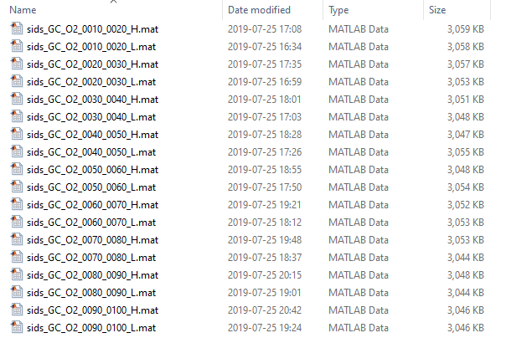

analized by

function aaout=anana_sid_sweep(pref,ants,thr,range)

% analysis after ana_sid_sweep

%

% pref prefix (ex.: sids_GC_O2_)

% ants cell array with at least two of 'L' 'H' 'V'

% thr threshold (def 1.e7)

% range def 10:10:1000

## **Typically interactive procedures**

### sid_sweep_tf

function sidstf=sid_sweep_tf(addr,ant,runame,freq,direc,sband,nSD,outband)

% time-frequency refinement of sid_sweep candidates

%

% sids=sid_sweep_tf(addr,ant,runame,freq,direc,sband)

%

% addr,ant,runame as for bsd_lego

% if addr is a bsd, use it

% if ant is a table, use it

% freq candidate frequency;

% if 2-dim freq(2), spin-down

% if 3-dim freq(3) is the semiband; def semiband 0.5 Hz

% direc direction structure

% sband search band (in units of 1/SD; typically 10)

% if present sband(2) = interlacing delay (in 1/SD)

% nSD time resolution in SD (typically integer); if 2-dim,

% nSD(2) interlacing shift (def nSD(2)=nSD(1)/2)

% nSD(3) resolution enhancement (def 2)

% outband output sub-band

% follow_cand_1

ant='ligol';

ant1='L';

pos='_GC_';

frcand=[80.03144716

200.2392189

203.9742236

227.7629126

488.3348368

524.3393044

531.1259047

716.0532049

930.3960485

1184.548527

1404.366458

1463.462946

1581.119174

1663.149171

1973.277106

2017.351895

]

frcand(1)=frcand(1)+0.47;

frcand(2)=frcand(2)+0.27;

frcand(9)=frcand(9)+0.17;

ncand=length(frcand);

for i = 13:ncand

candout=[ant1 pos num2str(frcand(i))];

ii=strfind(candout,'.')

candout(ii)='_';

eval([candout '=sid_sweep_tf(''J:'',''' ant ''',''O2'',frcand(i),GC,[10,5],7);'])

eval(['save(''' candout ''',''' candout ''')'])

end

creates files:

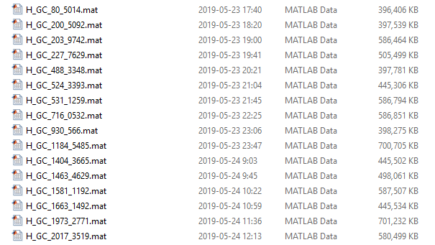

% follow_hinj_1

ant='ligol';

ant1='L_';

epoch=v2mjd([2017 1 1]);

for i = 13:14

puls=['pulsar_' num2str(i)];

eval([puls 'A=new_posfr(' puls ',epoch);'])

eval([ant1 puls '=sid_sweep_tf(''J:'',''' ant ''',''O2'',' puls 'A.f0,' puls ',[10,5],7);'])

eval(['save(''' ant1 puls ''',''' ant1 puls ''')'])

end

creates files:

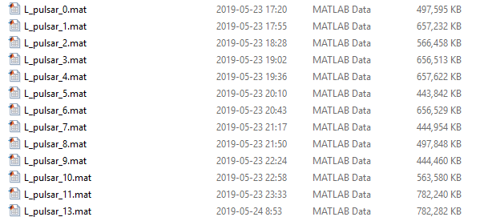

### sid_sweep_ref

function sidstf=sid_sweep_tf(addr,ant,runame,freq,direc,sband,nSD,outband)

% time-frequency refinement of sid_sweep candidates

%

% sids=sid_sweep_tf(addr,ant,runame,freq,direc,sband)

%

% addr,ant,runame as for bsd_lego

% if addr is a bsd, use it

% if ant is a table, use it

% freq candidate frequency;

% if 2-dim freq(2), spin-down

% if 3-dim freq(3) is the semiband; def semiband 0.5 Hz

% direc direction structure

% sband search band (in units of 1/SD; typically 10)

% if present sband(2) = interlacing delay (in 1/SD)

% nSD time resolution in SD (typically integer); if 2-dim,

% nSD(2) interlacing shift (def nSD(2)=nSD(1)/2)

% nSD(3) resolution enhancement (def 2)

% outband output sub-band

### sid_sweep_ref_multisband

function [sidsref,outpars]=sid_sweep_ref_multisband(addr,ant,runame,freq,direc,sbands,interl,check_sour)

% refinement of sid_sweep candidates on many sbands

%

% [sidsref,outpars]=sid_sweep_ref_multiband(addr,ant,runame,freq,direc,sbands,interl)

%

% addr,ant,runame as for bsd_lego

% if addr is a bsd, use it

% if ant is a table, use it

% freq candidate frequency;

% if 2-dim freq(2), spin-down

% if 3-dim freq(3) is the semiband; def semiband 0.5 Hz

% direc direction structure

% sbands search bands (in units of 1/SD; typically [10,100,1000])

% interl interlacing delay (in sband units; def 0.5)

% check_sour if present, for checking

### sid_sweep_ref_multidirec

function [sidsref,outpars]=sid_sweep_ref_multidirec(addr,ant,runame,freq,direcs,sband,check_sour)

% refinement of sid_sweep candidates on many sbands

%

% [sidsref,outpars]=sid_sweep_ref_multidirec(addr,ant,runame,freq,direc,sband,check_sour)

%

% addr,ant,runame as for bsd_lego

% if addr is a bsd, use it

% if ant is a table, use it

% freq candidate frequency;

% if 2-dim freq(2), spin-down

% if 3-dim freq(3) is the semiband; def semiband 0.5 Hz

% direcs cell array with direction structures

% sband search band (in units of 1/SD; typically 10)

% if present sband(2) = interlacing delay (in 1/SD)

% sband(3) = enlargement factor (def enl=10, min recommended 5)

% check_sour if present, for checking

% driver_sid_sweep_ref_multidirec

pp=new_posfr(pulsar_3,57859);

ppa=pp;

ppb=pp;

ppa.a=pp.a+5;

ppb.d=pp.d+5;

direc{1}=pp;

direc{2}=ppa;

direc{3}=ppb;

[sidsrefdir,outparsdir]=sid_sweep_ref_multidirec('I:','ligol','O2',pp.f0,direc,[10 5],pp)

### sid_sweep_multi

function [sids,bsdsstr]=sid_sweep_multi(bsdsstr,freq,direc,sband,nsid)

% multi antenna sid_sweep candidates

%

% sids=sid_sweep_multi(bsdsstr,freq,direc,sband,nsid)

%

% bsdsstr bsd search structure array (with addr,ant,runame as for bsd_lego)

% if it is a cell array containing bsds, use them

% freq candidate frequency;

% if 2-dim freq(2), spin-down

% if 3-dim freq(3) is the semiband; def semiband 0.5 Hz

% direc direction structure

% sband search band (in units of 1/SD; typically 10)

% if present sband(2) = interlacing delay (in 1/SD)

% sband(3) = enlargement factor (def enl=10, min recommended 5)

% nsid number of sidereal bins (def 24)

function [anas,selfr]=ana_multi_sids(sids,typ)

% analysis of multi_sids

%

% sids multi_sid output cell array

% typ type of analysis

% 0 base (def)

### bsd_noncohe_full

function [noncohe bsds]=bsd_noncohe_full(bsdsstr,band,direc,check_sour)

% non-coherent full analysis (not survey analysis)

%

% noncohe=bsd_noncohe_full(bsdsstr,band,direc,check_sour)

%

% bsdsstr bsd search structure array (with addr,ant,runame as for bsd_lego)

% or bsds cell array

% band frequency or band

% direc source direction

% check_sour inj or known source (if present)

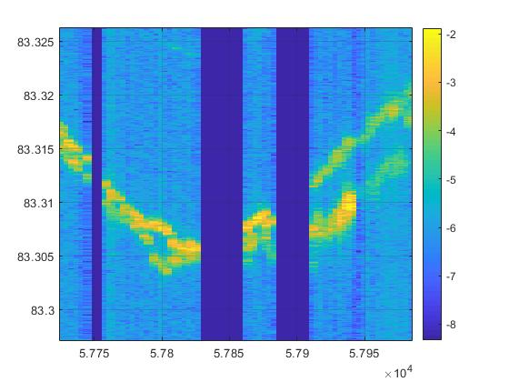

Line at 83 Hz, O2 LL

### Sidereal pattern analysis

function sidpat_base=ana_sidpat_base(ant,direc,N,res)

% sidpat_base to analyze sidereal pattern

%

% ant antenna (e.g. 'virgo')

% direc direction structure or cw-source structure

% N number of montecarlo samples for background evaluation (def no)

% -1: no background, full range (symmetrical)

% <-1: background with -N, full range (symmetrical)

% res resolution for eta and psi [neta,npsi] (def [201,90])

function out=ana_sidpat(sidpat,sidpat_base)

% analyze sidereal pattern

%

% sidpat sidereal pattern (array) or Fourier components abs val (0 1 2 3 4)

% sidpat_base sidpat_base, created by ana_sidpat_base

function out=ana_sidpat_n(ants,sidpats,direc)

% ana_sidpat for multiple antennas

%

% ants antennas cell array

% sidts sidpats cell array

% direc direction structure

% driver_ana_sidpat_n

pp=new_posfr(pulsar_3,57859)

pp=new_posfr(crab,57859)

pp.eta,pp.psi

sidpat_baseL=ana_sidpat_base(ligol,pp);

sidpat_baseH=ana_sidpat_base(ligoh,pp);

sidpat_baseV=ana_sidpat_base(virgo,pp);

[sidpatL,ftspL,vL]=pss_sidpat(pp,ligol,240,1);

[sidpatH,ftspH,vH]=pss_sidpat(pp,ligoh,240,1);

[sidpatV,ftspV,vV]=pss_sidpat(pp,virgo,240,1);

anaL=ana_sidpat(y_gd(sidpatL),sidpat_baseL);

anaH=ana_sidpat(y_gd(sidpatH),sidpat_baseH);

anaV=ana_sidpat(y_gd(sidpatV),sidpat_baseV);

spb_fit=anaL.spb_fit+anaH.spb_fit+anaV.spb_fit;

ants{1}=ligol;

ants{2}=ligoh;

ants{3}=virgo;

sidpats{1}=sidpatL;

sidpats{2}=sidpatH;

sidpats{3}=sidpatV;

out=ana_sidpat_n(ants,sidpats,pp);

eta1=out.ana{1}.eta0(1);

psi1=out.ana{1}.psi0(1);

eta2=out.ana{2}.eta0(1);

psi2=out.ana{2}.psi0(1);

eta3=out.ana{3}.eta0(1);

psi3=out.ana{3}.psi0(1);

fprintf('%s 0 -> %.2f %.0f 1 -> %.2f %.0f 2 -> %.2f %.0f 3 -> %.2f %.0f \n',pp.name,pp.eta,mod(pp.psi,90),eta1,psi1,eta2,psi2,eta3,psi3)

### Other

% bsd_block_noncohe_frsd

%

% non-coherent procedure to find fr and sd

% needs procedure bsd_block_1

% needs data sd1 and sd2

% produces bsd_out,BSD_tab_out,stpar

%

% bsd_block procedures: copy the script in the work folder

% with different name and modify

% do not modify original block

sd1=-1.e-12;

sd2=0.3e-12;

FS=1/SD;

Dfr=(-2:2)*FS;

xs=target.f0+Dfr;

[out_nc,bsd_ftr]=bsd_find_fr_sd(bsd_out,target,freq1,[sd1 sd2])

f5v=out_nc.f5v;

fprintf('Theoretical frequency %.7f Hz found %.7f Hz diff %d \n',xs(3),f5v.frs5v(3),f5v.frs5v(3)-xs(3))

plot_lines(xs,f5v.fil)

[v,tculm]=bsd_5vec(bsd_ftr,xs(3));

hol=bsd_hole_window(bsd_ftr,1);

sid=bsd_sid(bsd_ftr,target,100)

[v,tculm]=bsd_5vec(bsd_ftr,f5v.frs5v(3));

function [ratmap,intsig]=int_sid_sweep(sids,ints,typ,icsol)

% sid_sweep integration

%

% sids output of a sid_sweep

% ints integration windows (integer array)

% typ normalization (0 no, 1 yes, 2 sqr (def))

% icsol = 1 solar data (def 0 sidereal data)

### Service

function [map,pars]=fdf_rh_map(tfmap,typ,thr,maxslope,epoch)

% fdf hough or radon map

%

% tfmap time-frequency gd2 map

% typ type of output map

% thr threshold (in fraction: 0 all 1 only the maximum)

% maxslope max slope (> 0 ; 0 -> defauult)

% epoch any value, 0 beginning, 1 end

NC procedures

NC is the second version of the BSD noncohe library. The first version will become obsolete. The aspects of the NC are:

* rationalization and simplification
* correction
* velocity
* standardization of output file collection

The library is composed by

* the basic “engine” NC_sid_sweep_base
* first level analysis functions as NC_sid_sweep_multi, NC_sid_sweep,…
* batch functions as NC_crea_DC1,
* service functions, as NC_bsdcorr, NC_filnam,
* data collection analysis, as NC1_read,

## **Basic engine**

function [outsid,NCcom]=**NC_sid_sweep_base**(bsd_corr,direc,freq,NCcom)

% basic sid_sweep

%

% [outsid,NCcom]=NC_sid_sweep_base(bsd_corr,direc,freq,NCcom)

%

% bsd_corr corrected bsd (by e.g. NC_bsdcorr)

% direc direction structure ('nodirec' direction absent)

% freq candidate frequency;

% if 2-dim freq(2), spin-down

% if 3-dim freq(3) is the semiband; def semiband 0.5 Hz

% NCcom

% sband search band (in units of 1/SD; default 20) sband=0 -> 20

% interl interlacing delay (in 1/SD); default sband/2, if sband = 20, interl = 5

% enl enlargement factor (def 1)

% nsid number of sidereal bins (def or 0 = round(SD/outsid.DT))

%

% sol if exists and >0 -> also solar (NYI)

% checksolar if exist and = 1, substitutes SD with SolD

% if > 1, substitutes SD with checksolar

%

% nweek if present and >0, t-fr mode, n week for pieces (typically 1)

% dweek week interlacing delay (<= nweek, def nweek/2, =nweek or 0 no interlacing)

%

% post postfilter

% == 0 no

% == 1 basic (rectangular length round(sband/5)

% otherwise the MA filter

%

% out.ff 1 all, or indices [ini fin]

% out.POW 1 all, or indices [ini fin]

The output contains:

outsid.CHECKSOLAR=checksolar; can be absent

outsid.start=datetime('now');

outsid.ant=ant;

outsid.t0=t0;

outsid.dt=dt;

outsid.n=n;

outsid.Tobs=Tobs;

outsid.inifr=inifr;

outsid.bandw=bandw;

outsid.dfr=dfr;

outsid.band=band;

outsid.searband=sband(1);

outsid.interl=interl;

outsid.enl=enl;

outsid.i1=i1;

outsid.i2=i2;

outsid.weig=weig;

outsid.wnois=wnois;

outsid.microband=microband;

outsid.DFR=DFR;

outsid.DT=DT;

outsid.maxsidbins=maxsidbins;

outsid.nsid=nsid;

outsid.nweek=nweek;

outsid.dweek=dweek;

if nweek > 0

outsid.Nweek=Nweek;

end

outsid.NW=NW;

outsid.dNW=dNW;

outsid.post=post;

outsid.frdel=frdel;

outsid.fr=fr-frdel;

outsid.k1=k1;

outsid.K1=K1;

outsid.k2=k2;

outsid.N=N;

outsid.Y1=mean(abs(Y').^2);

outsid.Y2=mean(abs(Y).^2);

outsid.cover=cover;

for non-week mode:

outsid.sidsig=sidsig;

outsid.sidnois=sidnois;

outsid.sidzer=sidzer;

for week mode:

outsid.sidsigs=sidsigs;

outsid.sidnoiss=sidnoiss;

outsid.sidzers=sidzers;

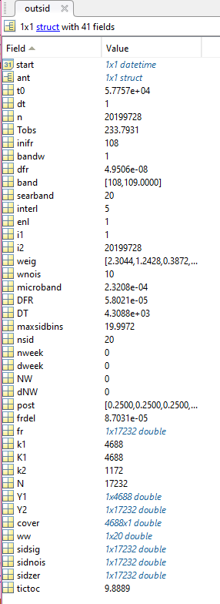

This function produces 3 arrays with the “signal”, the “sidereal noise” and the “non-sidereal noise”.

It can be used in two modes: noweek (only frequency) and week (time-frequency).

Solar periodicities can be checked.

## First level analysis

function [sids,bsdsstr]=NC_sid_sweep_multi(bsdsstr,direc,freq,NCcom)

% multi antenna sid_sweep candidates

%

% sids=sid_sweep_multi(bsdsstr,direc,freq,NCcom)

%

% bsdsstr bsd search structure array (with addr,ant,runame as for bsd_lego)

% if it is a cell array containing bsds, use them

% direc direction structure

% freq candidate frequency;

% if 2-dim freq(2), spin-down

% if 3-dim freq(3) is the semiband; def semiband 0.5 Hz

% NCcom

% sband search band (in units of 1/SD; default 20) sband=0 -> 20

% interl interlacing delay (in 1/SD); default sband/2, if sband = 20, interl = 5

% enl enlargement factor (def 1)

% nsid number of sidereal bins (def or 0 = round(SD/outsid.DT))

%

% sol if exists and >0 -> also solar

%

% nweek if present and >0, t-fr mode, n week for pieces (typically 1)

%

% out.ff 1 all, or indices [ini fin]

% out.POW 1 all, or indices [ini fin]

% use_multi

p3=new_posfr(pulsar_3,57859);

bsdsstr(1).addr='D:';

bsdsstr(1).ant='ligol';

bsdsstr(1).runame='O2';

bsdsstr(2).addr='D:';

bsdsstr(2).ant='ligoh';

bsdsstr(2).runame='O2';

[sids,bsds]=NC_sid_sweep_multi(bsdsstr,p3.f0,p3,[20 5 1])

% [sids,bsds]=NC_sid_sweep_multi(bsdsstr,[108.5,0,0.5],p3,[20 5 1])

function sidsw=NC_sid_sweep(addr,ant,runame,direc,freq,NCcom)

% sid sweep on a band

%

% sidsw=NC_sid_sweep(addr,ant,runame,direc,freq,NCcom)

%

% addr,ant,runame as for bsd_lego

% direc direction structure ('nodirec' direction absent)

% freq a frequency inside the bsd base band (10 Hz)

%

% NCcom

% frbase bsd frequency base (def 10)

% wband sub-band division (0.5,1,2,5,10 Hz; default 1 Hz)

% sband search band (in units of 1/SD; default 20) sband=0 -> 20

% interl interlacing delay (in 1/SD); default sband/2, if sband = 20, interl = 5

% enl enlargement factor (def 1)

% nsid number of sidereal bins (def or 0 = round(SD/outsid.DT))

%

% sol if exists and >0 -> also solar (NYI)

% checksolar if exist and = 1, substitutes SD with SolD

% if > 1, substitutes SD with checksolar

%

% nweek if present and >0, t-fr mode, n week for pieces (typically 1)

% dweek week interlacing delay (<= nweek, def nweek/2, =nweek or 0 no interlacing)

## Batch functions

function out=NC_crea_DC1(addr,ant,runame,direc,band,header,NCcom)

% creates a type 1 non-coherent DB

%

% out=NC_crea_DC1(addr,ant,runame,direc,band,header,NCcom)

%

% addr,ant,runame as for bsd_lego

% direc direction structure

% band min,max frequency bands (any value inside the first and the second

% header of the files (ex: 'GC')

%

% NCcom

% frbase bsd frequency base (def 10)

% wband sub-band division (0.5,1,2,5,10 Hz; default 1 Hz)

% sband search band (in units of 1/SD; default 20) sband=0 -> 20

% interl interlacing delay (in 1/SD); default sband/2, if sband = 20, interl = 5

% enl enlargement factor (def 1)

% nsid number of sidereal bins (def or 0 = round(SD/outsid.DT))

%

% sol if exists and >0 -> also solar (NYI)

% checksolar if exist and = 1, substitutes SD with SolD

% if > 1, substitutes SD with checksolar

%

% nweek if present and >0, t-fr mode, n week for pieces (typically 1)

% dweek week interlacing delay (<= nweek, def nweek/2, =nweek or 0 no interlacing)

function out=NC_crea_DC2(addr,ant,runame,direc,band,header,NCcom)

% creates a type 1 non-coherent DB

%

% out=NC_crea_DC2(addr,ant,runame,direc,band,header,NCcom)

%

% addr,ant,runame as for bsd_lego

% direc direction structure

% band min,max frequency bands (any value inside the first and the second

% header of the files (ex: 'GC')

%

% NCcom

% frbase bsd frequency base (def 10)

% wband sub-band division (0.5,1,2,5,10 Hz; default 1 Hz)

% sband search band (in units of 1/SD; default 20) sband=0 -> 20

% interl interlacing delay (in 1/SD); default sband/2, if sband = 20, interl = 5

% enl enlargement factor (def 1)

% nsid number of sidereal bins (def or 0 = round(SD/outsid.DT))

%

% sol if exists and >0 -> also solar (NYI)

% checksolar if exist and = 1, substitutes SD with SolD

% if > 1, substitutes SD with checksolar

%

% nweek if present and >0, t-fr mode, n week for pieces (typically 1)

% dweek week interlacing delay (<= nweek, def nweek/2, =nweek or 0 no interlacing)

function outmul=NC_crea_DC3(bsdsstr,cands,header,tail,NCcom)

% creates a type 3 non-coherent DB

%

% outmul=NC_crea_DC3(bsdsstr,cands,header,tail,NCcom)

%

% bsdsstr bsd search structure array (with addr,ant,runame as for bsd_lego)

% if it is a cell array containing bsds, use them

% cands list of sources (cell array)

% header of the files (ex: 'GC')

% tail filnam tail

%

% NCcom

% frbase bsd frequency base (def 10)

% wband sub-band division (0.5,1,2,5,10 Hz; default 1 Hz)

% sband search band (in units of 1/SD; default 20) sband=0 -> 20

% interl interlacing delay (in 1/SD); default sband/2, if sband = 20, interl = 5

% enl enlargement factor (def 1)

% nsid number of sidereal bins (def or 0 = round(SD/outsid.DT))

%

% sol if exists and >0 -> also solar (NYI)

% checksolar if exist and = 1, substitutes SD with SolD

% if > 1, substitutes SD with checksolar

%

% nweek if present and >0, t-fr mode, n week for pieces (typically 1)

% dweek week interlacing delay (<= nweek, def nweek/2, =nweek or 0 no interlacing)

function outmul=NC_crea_DC4(bsdsstr,cands,header,tail,NCcom)

% creates a type 4 non-coherent DB

%

% outmul=NC_crea_DC4(bsdsstr,cands,header,tail,NCcom)

%

% bsdsstr bsd search structure array (with addr,ant,runame as for bsd_lego)

% if it is a cell array containing bsds, use them

% cands list of sources (cell array)

% header of the files (ex: 'GC')

% tail filnam tail

%

% NCcom

% frbase bsd frequency base (def 10)

% wband sub-band division (0.5,1,2,5,10 Hz; default 1 Hz)

% sband search band (in units of 1/SD; default 20) sband=0 -> 20

% interl interlacing delay (in 1/SD); default sband/2, if sband = 20, interl = 5

% enl enlargement factor (def 1)

% nsid number of sidereal bins (def or 0 = round(SD/outsid.DT))

%

% sol if exists and >0 -> also solar (NYI)

% checksolar if exist and = 1, substitutes SD with SolD

% if > 1, substitutes SD with checksolar

%

% nweek if present and >0, t-fr mode, n week for pieces (typically 1)

% dweek week interlacing delay (<= nweek, def nweek/2, =nweek or 0 no interlacing)

## Service functions

function bsd_corr=NC_bsdcorr(addr,ant,runame,band,direc)

% creates Doppler corrected bsds

%

% bsd_corr=NC_bsdcorr(addr,ant,runame,direc)

%

% addr,ant,runame as for bsd_lego

% band [frini frfin] ; if length(freq) = 1 or frini=frfin

% the full band with frini (def ortho-band)

% direc direction structure ('nodirec' or 0 no correction)

function filnam=NC_filnam(typ,header,runame,ant,band,dats,tail)

% name of NC collections files

%

% typ 1 DB1

% header ex.: 'DB1_GC'

% ant ex.: 'virgo'

% band [min max]

% dats other (1 or more numbers)

% tail suffix (if present)

## Data collection analysis

function [par,sig,nois,zer]=NC1_read(addr,ant,runame,head,band,plt)

% reads data from NC1 file collection

%

% [out,par]=NC1_read(addr,ant,runame,head,band)

%

% addr,ant,runame as for bsd_lego

% head file name header (ex.: 'GC')

% band min,max frequency

% plt > 0, plots

function [par,sigs,noiss,zers,sig,nois,zer]=NC2_read(addr,ant,runame,head,band,plt)

% reads data from NC1 file collection

%

% [out,par]=NC1_read(addr,ant,runame,head,band)

%

% addr,ant,runame as for bsd_lego

% head file name header (ex.: 'GC')

% band min,max frequency

% plt > 0, plots

function out=NC4_read(fil,kcand,typ,plt)

% reads data from NC3 or NC4 file

%

% out=NC4_read(fil,kcand,typ,plt)

%

% fil type NC3 or NC4 file

% kcand candidate number (0 or absent, list)

% typ 1 only frequency, 2 time frequency

% plt plot type (def no)

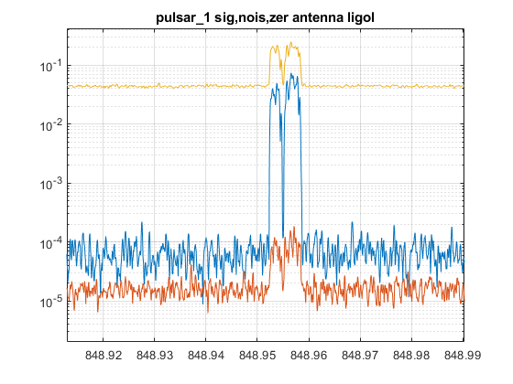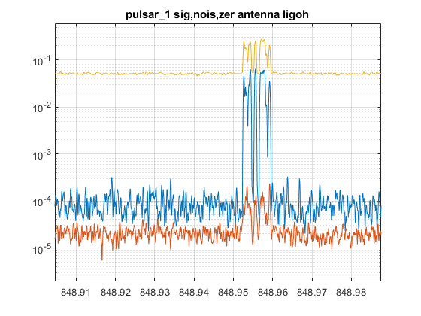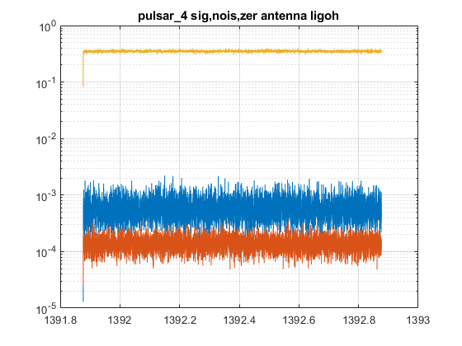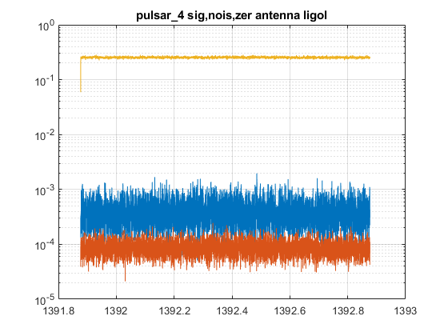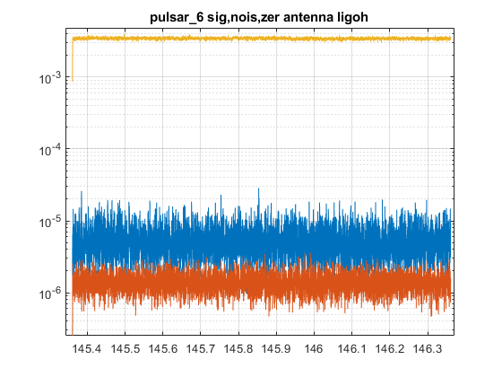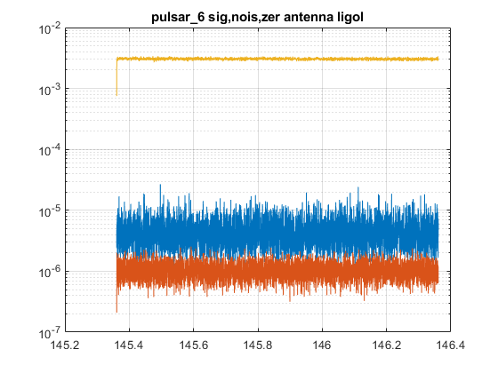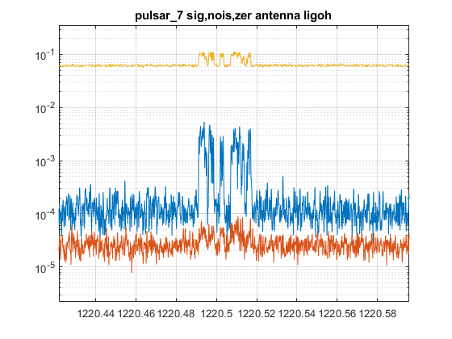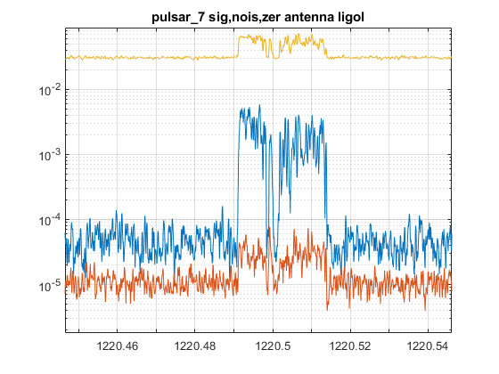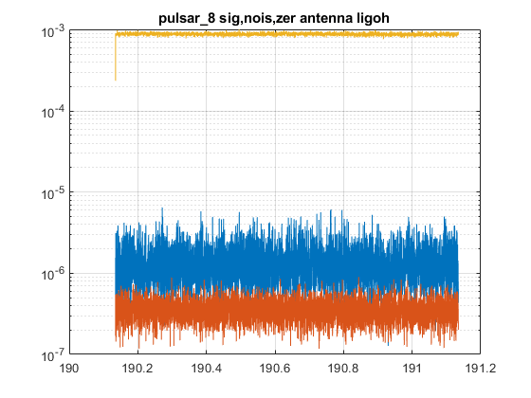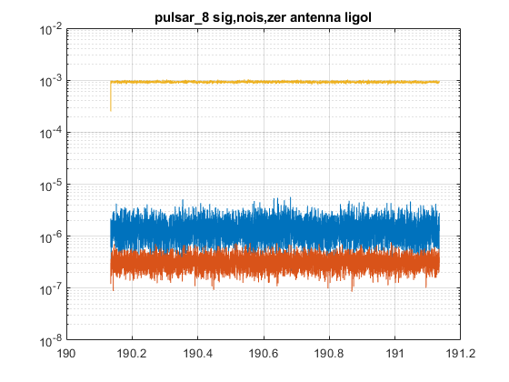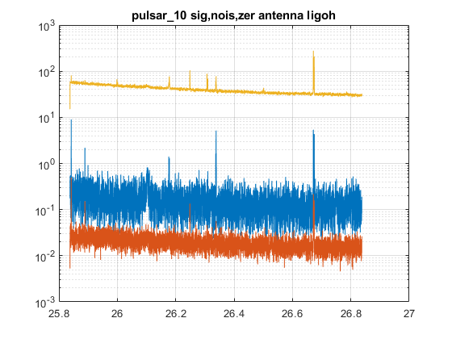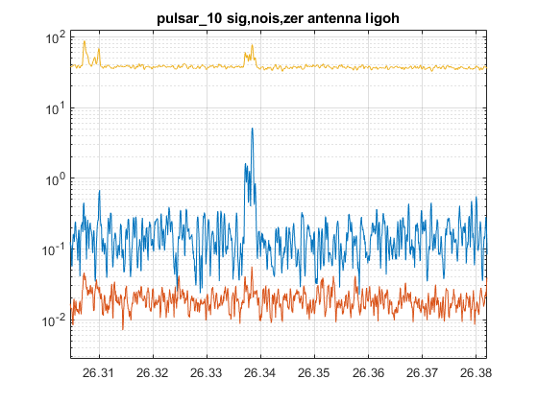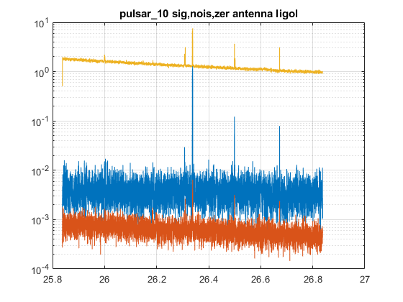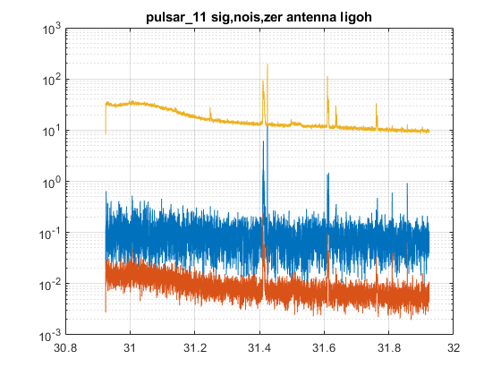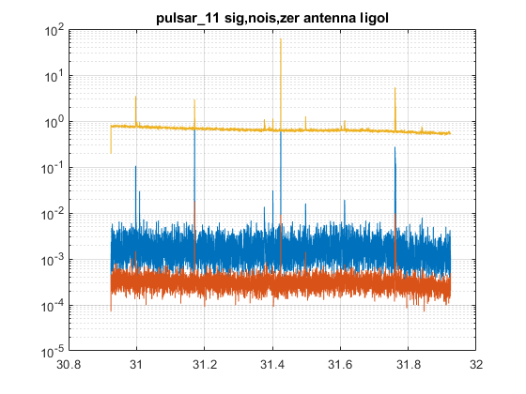

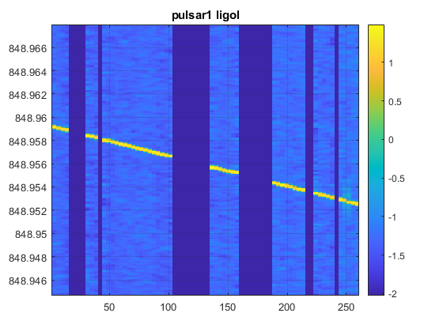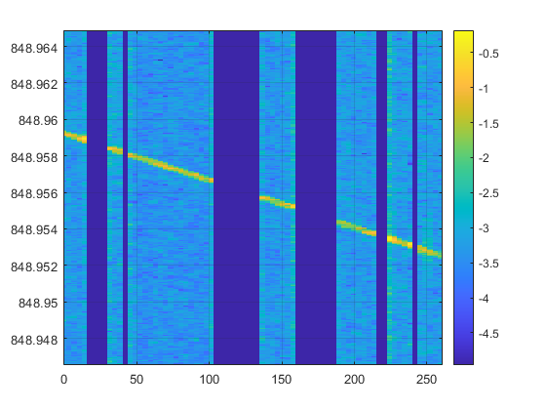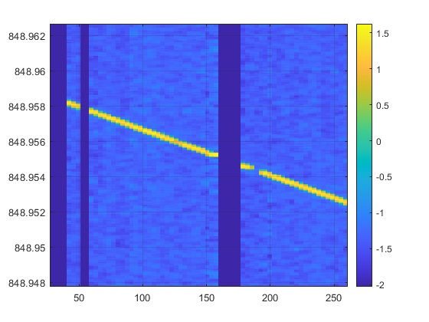

BSD GUIs

function bsds_addr_tab=bsds_gui()

% gui to create bsds_addr_tab

% Snag Version 2.0 - April 2021

% show_multiant

prompt={'dt0'...

'equifreq'...

'orthoband'...

'no T_mean'...

'no correction'...

'spectral resolution (or 0)'...

'raw out'...

'frequency shift'...

'Output bandwidth'...

'Output structure name'};

defarg={'0.1' '1' '1' '0' '0' '2' '0' '0' '0.5' 'MAout'};

answ=inputdlg(prompt,'Multi Antenna parameters',[1,40],defarg);

MAcom.dt0=eval(answ{1});

MAcom.equifreq=eval(answ{2});

MAcom.orthoband=eval(answ{3});

MAcom.noT_mean=eval(answ{4});

MAcom.nocorr=eval(answ{5});

MAcom.specres=eval(answ{6});

MAcom.rawout=eval(answ{7});

MAcom.frshift=eval(answ{8});

wband=eval(answ{9});

outstnam=answ{10};

eval([outstnam '=bsd_multiant(bsds_addr_tab,sour,wband,MAcom)'])

BSD procedures

% addobba3

anabasic.tfh_thr=95;

anabasic.noplot=1;

% list='list_O1_L_raw.txt';

%

% outL=bsd_tfstr_add(list,anabasic)

list='list_O1_L_sccl.txt';

outH=bsd_tfstr_add(list,anabasic)

% addobba_notch

anabasic.tfh_thr=95;

anabasic.noplot=1;

lines=ligo_readlines('O2L1lines.csv');

parnotch.lines=lines;

parnotch.thr=0.25;

parnotch.win=1;

% list='list_O1_L_raw.txt';

%

% outL=bsd_tfstr_add(list,anabasic)

list='list_O2_L_sccl.txt';

outH=bsd_tfstr_addwithnotch(list,parnotch,anabasic)

% add_notch_to_tfstr_files

%

% work in a different folder than the source files

lines=ligo_readlines('O2L1lines.csv');

parnotch.lines=lines;

parnotch.thr=0.25;

parnotch.win=1;

list='list_O2_L_tfstr.txt';

fidlist=fopen(list,'r');

nfiles=0;

nofiles=0;

while (feof(fidlist) ~= 1)

str=fgetl(fidlist);

str1=str(1);

if strcmp(str1,'*')

nofiles=nofiles+1;

fprintf(' %s NOT CONSIDERED \n',str);

continue

else

nfiles=nfiles+1;

file{nfiles}=str;

fprintf(' %s \n',str);

end

end

nfiles,nofiles

for i = 1:nfiles

[pathstr,name,ext]=fileparts(file{i});

load(file{i});

name

eval([name '=bsd_notch(' name ',parnotch);'])

eval(['save(''' name ''',''' name ''',''-v7.3'')'])

eval(['clear ' name])

end

% sHapplier

% gdin=g2

gdin=lvela;

ant=ligol;

name='outLvela'

sour=vela;

cont=cont_gd(gdin);

t0=cont.t0;

sournew=new_posfr(sour,t0)

fr=sournew.f0;

fr=[sournew.f0,sournew.df0,sournew.ddf0];

VPstr=extr_velpos_gd(gdin)

[pO,vO,tO,psO,vsO,ttO]=interp_VP(VPstr,sour);

eval([name '_5vec=sa_spec5vec(sournew,ant,-1);'])

eval(['[' name ',corr]=vfs_subhet_pos(gdin,fr,pO);'])

eval(['s' name '=gd_pows(' name ');'])

eval(['figure;semilogy(' 's' name '); grid on'])

N=n_gd(gdin);

dt=dx_gd(gdin);

gdpar=[dt,N];

sdpar=fr(2:length(fr));

eval('sd=vfs_spindown(gdpar,sdpar,1);')

eval([name '_sd=vfs_subhet(' name ',sd)'])

eval(['s' name '_sd=gd_pows(' name '_sd);'])

fs=sa_spec5vec(sournew,ant,-1);

eval(['figure;semilogy(' 's' name '_sd); grid on'])

eval(['plot_lines(fs(1,:),' 's' name '_sd);'])

# BSD analysis procedures

function s=bsd_pows(bsd,res,pieces,windn)

% bsd power spectrum

%

% bsd input bsd

% res resolution

% pieces number of pieces (def 1)

% windn window number (0 -> no, 1 -> bartlett, 2 -> hanning, 3 -> flatcos, 4 -> tukey)

% def hanning

% Snag Version 2.0 - December 2016

function w=bsd_worm(bsd,freq,icshow)

% worm for bsd

%

% bsd bsd input

% freq frequency (not aliased)

% icshow = 1 plot

% Snag Version 2.0 - December 2016

function v=bsd_5vec(bsd,frs)

% computes the 5-vec for a bsd

%

% out=bsd_5vec(bsd,frs)

%

% bsd input bsd

% frs frequencies

% Snag Version 2.0 - December 2016

function out=bsd_piece_5vec(in,fr,dt1,dt2,rasc)

% computes the 5-vect for pieces

%

% out=bsd_piece_5vec(in,fr,dt1,dt2)

%

% in input bsd

% fr frequency

% dt1 distance between pieces (in SidDays)

% dt2 length of pieces (in SidDays)

% Snag version 2.0 - January 2017

function out=bsd_specfilt(in,sourd,res)

% applies spectral filter to a bsd

%

% out=bsd_specfilt(in,sour,res)

%

% in input bsd

% sourd source declination (deg) or source

% res resolution

% Snag Version 2.0 - January 2017

function out=bsd_sid(in,fr,nsid)

% sidereal analysis (gmst)

%

% in input bsd

% fr frequency

% nsid length of the

% Snag Version 2.0 - January 2017

function [s,pieces,lenpiec]=bsd_lowres_pows(bsd,res,lcohe,windn)

% low resolution spectrum

%

% s=bsd_lowres_pows(bsd,res,lcohe,windn)

%

% bsd input bsd

% res 0-padding resolution enhancement

% lcohe coherence length (days or s)

% windn window number (0 -> no, 1 -> bartlett, 2 -> hanning, 3 -> flatcos, 4 -> tukey)

% def hanning

% Snag Version 2.0 - January 2017

function out=check_inj(in,sour,ichole)

% Check injection

%

% in input bsd (not corrected)

% sour source or injection

% ichole > 0 insert input holes (def 1)

% Snag Version 2.0 - February 2017

# Non-bsd useful functions

## Service

function out=stat_nonzero(gin)

% statistics on non-zero data

%

% out=stat_nonzero(gin)

%

% gin arragin, gd or gd2

% Snag Version 2.0 - November 2016

function tfstr=tfstr_gd(gin)

% extracts tfstr structure

% Version 2.0 - September 2016

function [y,mi]=logarithmize(x)

% reduce drastically the dynamics

%

% [y,mi]=logarithmize(x)

%

% x input gd or array

%

% mi median abs level (*10 typical threshold)

% Version 2.0 - April 2016

function cl=complex_clip(in,thr)

% puts to zero values of a complex gd with higher than thr abs values

%

% cl=complex_clip(in,thr)

%

% Snag Version 2.0 - April 2016

function out=extr_band(in,band,st)

% extract band (output signal is complex)

% out=extr_band(in,band,st)

%

% in input gd (type 1)

% band [min max] frequency

% st sampling time (if present; otherwise st=1/band)

% Snag Version 2.0 - June 2016

function out=double_threshold(in,th1,th2,amp)

% double threshold function

%

% out=double_threshold(in,th1,th2,amp)

%

% in input array or gd or gd2

% th1 exclusion threshold

% th2 saturation threshold

% amp max amplitude (def 1)

% Version 2.0 - February 2017

## VFS (Varying Frequency Signal)

* **vfs_create**

function [gout,fr,lfr,fr0,ph0]=vfs_create(n,dt,pols,sins,inp)

% create varying frequency signals

%

% [gout,fr,lfr,fr0,ph0]=vfs_create(n,dt,pols,sins,inp)

%

% n number of samples

% dt sampling time (negative -> complex signal)

% pols polinomial coefficient (1 fr0, 2 sd, ...)

% pols(1) can be complex (fr0+j*ph0 (ph0 in deg))

% sins sinusoids (m,3) (A,fr,ph(deg))

% inp irregular input frequency (if exist; will be resampled to n)

%

% ex.: [gout,fr,lfr,fr0,ph0]=vfs_create(10000,-0.1,1,[0.1,0.01,0]);

function gout=vfs_create_1(n,dt,fr0,frph,ic)

% create varying frequency signals

%

% gout=vfs_create_1(n,dt,fr0,frph,ic)

%

% n number of samples

% dt sampling time (negative -> complex signal)

% fr0 main frequency

% frph varying frequency or phase

% ic = 0 frequecy additive

% = 1 frequency multiplicative

% = 2 phase

function gout=vfs_create_2(gin,frph,ic)

% create varying frequency signals

%

% gout=vfs_create_1(n,dt,fr0,frph,ic)

%

% gin input gd analytic signal

% frph varying frequency or phase

% ic = 0 frequecy

% = 1 phase

* **vfs_freq**

function [fr,fr1,fr2,dy,dy1,dy2]=vfs_freq(in,cal)

% frequency evaluation

%

% in input gd (complex (if real, it is converted to analytical signal)

% cal > 0 -> calibrated (only on fr), > 1 calibration curve

* **vfs_subhet**

function [out,lfr1]=vfs_subhet(in,lfr)

% application of sub-heterodyne

%

% [out,lfr]=vfs_subhet(in,lfr)

%

% in input data gd

% lfr sub-het varying frequency

function out=vfs_subhet_pos(in,fr,pos)

% application of sub-heterodyne

%

% [out,lfr]=vfs_subhet_pos(in,fr,pos)

%

% in input data gd

% fr frequency (fixed or varying as fr(1)*(1+dfr*t))

% pos position (normalized by c)

* **vfs_spindown**

function sd= (gpar,sdpar,ic)

% creation/correction spin-down frequency variation

%

% sd=vfs_spindown(gin,sdpar,ic)

%

% gpar data gd dt and n

% sdpar spin-down parameters array at epoch ini of the gd

% ic 1/-1 creation/correction

function spfilt=crea_spec_filter(sour,ant)

% computes the mean spectral filter

%

% out=spec_filter(sour,ant)

% Version 2.0 - July 2016

## MC Filter

function out=mc_5vec(ant,sour,N,randph,icplot)

% montecarlo with 5-vect

%

% ant antenna (0 -> all parameters

% ant struct -> fixed antenna)

% sour source (0 -> all parameters

% [alpha,delta] -> fixed position

% sour struct -> fixed source)

% N MC dimension

% randph random phase (source RA: 0 or 1; def 0)

function MCF=crea_mc_filter(ant,sour,N,randph)

% create a

%

% ant antenna (0 -> all parameters

% ant struct -> fixed antenna)

% sour source (0 -> all parameters

% [alpha,delta] -> fixed position

% sour struct -> fixed source)

% N MC dimension

% randph random phase (source RA: 0 or 1; def 0)

function out=mc_filter(MCF,in,ic)

% 5-vect montecarlo filtering

%

% MCF mc filter bank [5,N]

% in input 5-vects [5,n]

% ic plot level

function [sig,nois,sigeta,sigpsi]=mc_sn_5vec(ant,sour,N,randph)

% montecarlo with 5-vect

%

% ant antenna (0 -> all parameters

% ant struct -> fixed antenna)

% sour source (0 -> all parameters

% [alpha,delta] -> fixed position

% sour struct -> fixed source)

% N MC dimension

% randph random phase (source RA: 0 or 1; def 0)

% test_mcf_10

%

% spectral filter and mc filter

% testing also flat filter and max filter

# Example scripts

## Extracting events

% ex_bsd_event

%

% data extraction in a band [30 300] Hz

% ±5 min around the exact minute

%

% whitening filter and time resolution enhancement

% complex to real conversion

tic

MJD=57279.410247905;

mjd_day=floor(MJD);

mjd_min=floor((MJD-mjd_day)*1440)/1440;

min5=5/1440;

t1=mjd_day+mjd_min-min5; mjd2s(t1)

t2=mjd_day+mjd_min+min5; mjd2s(t2)

[bsd_outL,BSD_tab_outL,outL]=bsd_access('I:','ligol','O1',[t1 t2],[30 300],3);

[bsd_outH,BSD_tab_outH,outH]=bsd_access('I:','ligoh','O1',[t1 t2],[30 300],3);

disp('Data extraction'),toc

[whL,filthL]=bsd_frfilt(bsd_outL,'white');

[whH,filthH]=bsd_frfilt(bsd_outH,'white');

figure;plot(whL),hold on,plot(whH,'r');

WHL=bsd_resenh(whL,10);

WHH=bsd_resenh(whH,10);

figure;plot(WHL);hold on;plot(WHH,'r');plot(whL,'r.');plot(whH,'b.')

rWHL=bsd_real(WHL);

rWHH=bsd_real(WHH);

figure;plot(rWHL);hold on;plot(rWHH,'r');

mjd2s(t1),mjd2s(t2)

disp('End'),toc

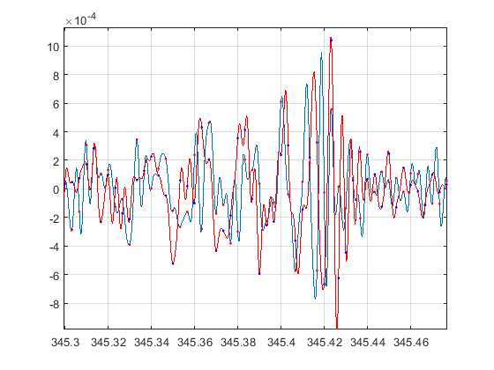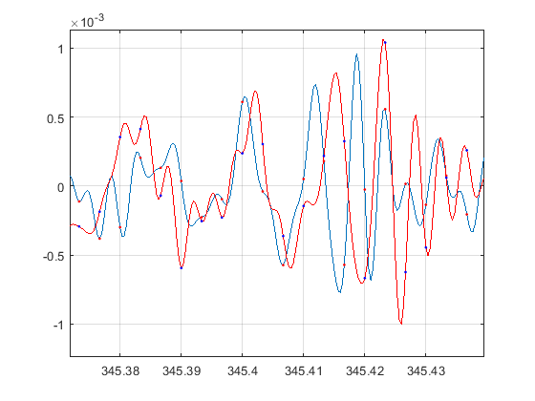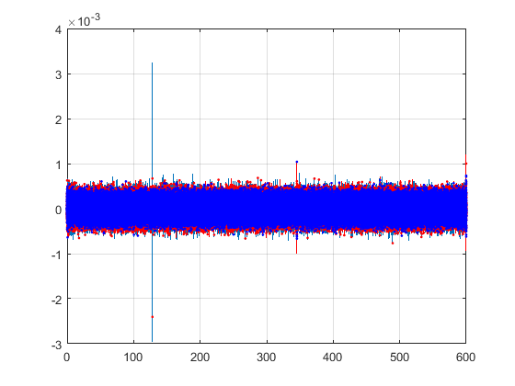

## Extracting narrow bands

% ex_bsd_sband

%

% extracts a band around the pulsar_3

tic

pp=pulsar_3;

fr=pp.f0;

dfr=0.1;

[bsd_outL,BSD_tab_outL,outL]=bsd_access('I:','ligol','O1',[57270 57570],[fr-dfr fr+dfr],2);

[bsd_outH,BSD_tab_outH,outH]=bsd_access('I:','ligoh','O1',[57270 57570],[fr-dfr fr+dfr],2);

toc

## Correction of Doppler and spin-down

% ex_bsd_dedop

%

% after ex_bsd_sband

tic

pp0=pulsar_3;

SD=86164.09053083288;

cont=cont_gd(bsd_outL);

t0=cont.t0;

fr0=cont.inifr;

% x=x_gd(bsd_outL);

pp=new_posfr(pp0,t0);

Dfr=pp.f0-pp0.f0;

bsd_corrL=bsd_dopp_sd(bsd_outL,pp);

bsd_corrH=bsd_dopp_sd(bsd_outH,pp);

sL=gd_pows(bsd_corrL,'resolution',6);

sH=gd_pows(bsd_corrH,'resolution',6);

figure,plot(sL,sH)

frcent=pp.f0-fr0;

xs=frcent+[-2 -1 0 1 2]/SD;

figure,plot(sL,sH),plot_lines(xs,sL,'g')

xlim([frcent-5/SD frcent+5/SD])

toc

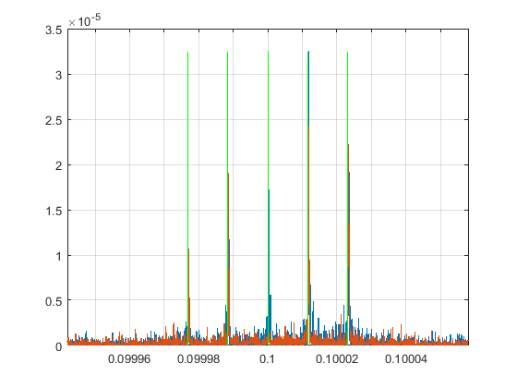

% ex_bsd_dedop_sing

%

% from the bsd primary file

tic

pp0=pulsar_3;

SD=86164.09053083288;

cont=cont_gd(L_C01_20151112_0100_0110_tfstr);

t0=cont.t0;

fr0=cont.inifr;

pp=new_posfr(pp0,t0);

Dfr=pp.f0-pp0.f0;

bsd_corrL=bsd_dopp_sd(L_C01_20151112_0100_0110_tfstr,pp);

sL=gd_pows(bsd_corrL,'resolution',2);

frcent=pp.f0-fr0;

xs=frcent+[-2 -1 0 1 2]/SD;

figure,semilogy(sL),plot_lines(xs,sL,'g')

xlim([frcent-5/SD frcent+5/SD]),grid on

toc

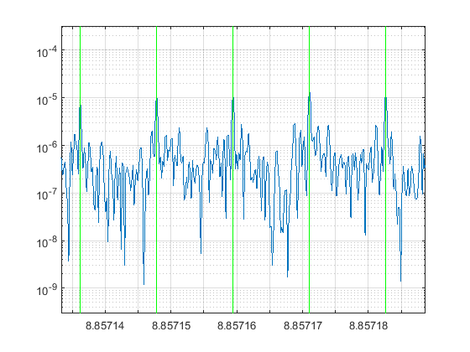

## Software injections

Using bsd_acc_modif, internally to bsd_access and load_tab_bsd.

% ex_bsd_modif

tic

dfr=0.1;

modif.typ='sinsig';

modif.t00=57270;

modif.fr=108.8;

modif.ph=0;

modif.amp=1;

% modif=[];

modifpost.typ='sinsig';

modifpost.t00=57270;

modifpost.fr=108.8;

modifpost.ph=0;

modifpost.amp=1;

modifpost=[];

fr=modif.fr;

[bsd_outL,BSD_tab_outL,outL]=bsd_access('I:','ligol','O1',[57270 57570],[fr-dfr fr+dfr],2,modif,modifpost);

toc

% ex_bsd_softinj

tic

SD=86164.09053083288;

dfr=0.1;

modif.typ='source';

pp=pulsar_3;

pp.f0=pp.f0-1;

modif.sour=pp;

modif.phs=[0 0 0];

modif.A=1;

% modif=[];

modifpost.typ='source';

modifpost.sour=pp;

modifpost.phs=[0 0 0];

modifpost.A=1;

modifpost=[];

fr=pp.f0;

[bsd_sinj_L,BSD_tab_outL,outL]=bsd_access('I:','ligol','O1',[57270 57570],[fr-dfr fr+dfr],2,modif,modifpost);

bsd_corrsinj_L=bsd_dopp_sd(bsd_sinj_L,pp);

cont=cont_gd(bsd_sinj_L);

t0=cont.t0;

fr0=cont.inifr;

sL=gd_pows(bsd_corrsinj_L,'resolution',6);

figure,plot(sL)

frcent=pp.f0-fr0;

xs=frcent+[-2 -1 0 1 2]/SD;

figure,plot(sL),plot_lines(xs,sL,'g')

xlim([frcent-5/SD frcent+5/SD])

toc

## Compute 5-vec

% ex_bsd_5vec

%

% after ex_bsd_sband and ex_bsd_dedop

bsd=bsd_corrL;

tic

t0_O1=57277;

pp=pulsar_3; % not updated sources !

pp=new_posfr(pp,t0_O1);

f0=pp.f0;

df=1.e-8;

frs=(-15:15)*df+f0;

n=length(frs);

v=bsd_5vec(bsd,frs);

for i = 1:n

vnorm(i)=norm(v(:,i));

end

vabs=abs(v);

vang=angle(v)*180/pi;

for j = 1:5

vang1(j,:)=atan3(v(j,:));

end

frs1=frs(1:n-1)+df/2;

figure,plot(frs,vnorm),grid on,title('Norm')

plot_lines(f0,vnorm,'g')

[vmax,imax]=max(vnorm);

fmax=frs(imax);

plot_lines(fmax,vnorm,'r')

figure,plot(frs,vabs(1,:),'r'),grid on

hold on,plot(frs,vabs(2,:),'m')

hold on,plot(frs,vabs(3,:),'k')

hold on,plot(frs,vabs(4,:),'g')

hold on,plot(frs,vabs(5,:),'b'),title('Absolute values')

vabsmax=max(vabs);

plot_lines(f0,vabsmax,'g')

plot_lines(fmax,vabsmax,'r')

figure,plot(frs,vabs(1,:)./vabsmax,'r'),grid on

hold on,plot(frs,vabs(2,:)./vabsmax,'m')

hold on,plot(frs,vabs(3,:)./vabsmax,'k')

hold on,plot(frs,vabs(4,:)./vabsmax,'g')

hold on,plot(frs,vabs(5,:)./vabsmax,'b'),title('Normalised absolute values')

vabsmax=max(vabs);

plot_lines(f0,[0 1.05],'g')

plot_lines(fmax,[0 1.05],'r')

figure,plot(frs,vang(1,:),'r'),grid on

hold on,plot(frs,vang(2,:),'m')

hold on,plot(frs,vang(3,:),'k')

hold on,plot(frs,vang(4,:),'g')

hold on,plot(frs,vang(5,:),'b'),title('Angles')

plot_lines(f0,vang(:),'g')

plot_lines(fmax,vang(:),'r')

figure,plot(frs,vang1(1,:),'r'),grid on

hold on,plot(frs,vang1(2,:),'m')

hold on,plot(frs,vang1(3,:),'k')

hold on,plot(frs,vang1(4,:),'g')

hold on,plot(frs,vang1(5,:),'b'),title('Angles (in turns)')

plot_lines(f0,vang1(:),'g')

plot_lines(fmax,vang1(:),'r')

figure,plot(frs1,diff(vang1(1,:)),'r'),grid on

hold on,plot(frs1,diff(vang1(2,:)),'m')

hold on,plot(frs1,diff(vang1(3,:)),'k')

hold on,plot(frs1,diff(vang1(4,:)),'g')

hold on,plot(frs1,diff(vang1(5,:)),'b'),title('Angles differences')

plot_lines(f0,diff(vang1(:))/4,'g')

plot_lines(fmax,diff(vang1(:))/4,'r')

toc

## equi_example

% equi_example

addr='F:';

%-------------------------------

% simple

[bsd_out,BSD_tab_out,stpar]=bsd_equilego(addr,'BSD_O3_L',0,[108 109])

figure,plot(bsd_out)

cont=cont_gd(bsd_out);

T=cont.t0+100; % approximate epoch

sour=pulsar_3;

sour=new_posfr(sour,T);

bsd_corr=bsd_dopp_sd(bsd_out,sour,-1); % doppler and spin-down correction

spec=bsd_pows(bsd_corr,2)

spmean=mean(spec)

SD=86164.09053083288;

xs=sour.f0+[-2 -1 0 1 2]/SD;

figure,semilogy(spec),plot_lines(xs,spec,'g'),grid on

ylim([spmean*0.5 spmean*200])

pause(5)

xlim(sour.f0+[-1:2:1]*30/SD)

pause(5)

xlim(sour.f0+[-1:2:1]*3/SD)

%-------------------------------

% multiant for an optimezed analysis

clear bsds_adr_tab

bsds_addr_tab(1).addr=addr;

bsds_addr_tab(1).tab='BSD_O3_L';

bsds_addr_tab(2).addr=addr;

bsds_addr_tab(2).tab='BSD_O3_H';

bsds_addr_tab(3).addr=addr;

bsds_addr_tab(3).tab='BSD_O3_V';

[parants,Dt_max]=check_bsdsstr(bsds_addr_tab); % create parants (used in bsd_multiant_equi)

parants

wband=0.5; % MAcom is default

out=bsd_multiant_equi(bsds_addr_tab,sour,wband)

% MAcom describes the way of doing things; it is created by show_multiant_equi or show_multiant_equi_full:

% otherwise the default are used

% Interactive setting for multiant

% previously create bsds_addr_tab and the sour (ex.: sour=pulsar_3)

show_multiant_equi

% or show_multiant_equi_full

%-------------------------------

% hardware injection management

% load the table cwinj_O3 (or cwinj_O2); it is in \Snag\projects\gw\sources\gw_ps .

pulsar=read_cwinj_table(cwinj_O3,7) % creates the pulsar 7

all_hard_inj % creates all the injected pulsars as single structures and

% as the full collection in a cell array named puls

# Code Blocks (“BSD snippets”)

In order to simplify the use of BSDs and establish standard procedures, **code blocks** have been introduced. They are a standard collection of scripts that should be

* copied in the local work folder
* renamed in order to not be confounded
* modified as needed
* used as such or put in another script

These blocks use the BSD global variables.

Some code blocks:

* bsd_block_0

% bsd_block_0

%

% defines the search parameters

%

% bsd_block procedures: copy the script in the work folder

% with different name and modify

% do not modify original block

global bsd_glob_noplot bsd_glob_level

bsd_glob_set=reset_bsd_glob()

addr='I:';

ant='ligol';

runame='O2';

tim=1;

target=pulsar_3;

SD=86164.09053083288;

* bsd_block_1

% bsd_block_1

%

% extracts data to analyze

% needs procedure bsd_block_0

% needs data extr_half_band

% produces bsd_out,BSD_tab_out,stpar

%

% bsd_block procedures: copy the script in the work folder

% with different name and modify

% do not modify original block

extr_half_band=0.05;

frdum=target.f0;

freqdum=[frdum-extr_half_band,frdum+extr_half_band];

BSD_tab_out=bsd_tabout(addr,ant,runame,tim,freqdum);

ntab=length(BSD_tab_out.t_ini);

T00=(BSD_tab_out.t_ini(1)+BSD_tab_out.t_fin(ntab))/2;

T0=BSD_tab_out.t_ini(1);

Tobs=(BSD_tab_out.t_fin(ntab)-BSD_tab_out.t_ini(1))*86400;

dsd0=1/Tobs^2; dsd=dsd0

target=new_posfr(target,T0);

frdec=target.f0;

freq=[frdec-0.05,frdec+0.05];

freq1=[frdec-5.1/SD,frdec+5.1/SD];

mode=1; target

* bsd_block_noncohe_frsd

% bsd_block_noncohe_frsd

%

% non-coherent procedure to find fr and sd

% needs procedure bsd_block_1

% needs data sd1 and sd2

% produces bsd_out,BSD_tab_out,stpar

%

% bsd_block procedures: copy the script in the work folder

% with different name and modify

% do not modify original block

* bsd_block_fr_sd_lowres

% bsd_block_fr_sd_lowres

%

% low-resolution non-coherent procedure to find fr and sd

% needs procedure bsd_block_1

% needs data npiece, SDband, sd1 and sd2

% par search parameters (there is a default)

% .nl raw search reduction factor (def 5)

% .nh refined search enhancement factor (def 2)

% .refb refinement band (in natural units, def 5)

% .enl enlargement factor for bsd_trim

% produces bsd_out,BSD_tab_out,stpar

%

* bsd_block_sidpat

% bsd_block_sidpat

%

% produces and analyze the sidereal pattern

% needs bsd_ftr

%

* bsd_block_sid_ana

% bsd_block_sid_ana

%

% sidereal analysis

% needs procedure bsd_block_1

% produces bsd_out,BSD_tab_out,stpar

* bsd_block_modify_target

% bsd_block_modify_target

%

% simply modification of target

Examples of use:

% ex_bsd_zoomcand_nosd

%

%

bsd_block_0

bsd_block_1

bsd_block_noncohe_frsd

-----------------------

% check_noncohe_pos_sid_error

bsd_block_0

bsd_block_1

bsd_glob_noplot=1

target0=target;

da=0.1;

dd=0.1;

na=5;

nd=4;

snrout=zeros((2*na+1),(2*nd+1));

snrout2=snrout;

maxout=snrout;

as=(-na:na)*da;

ds=(-nd:nd)*dd;

ii=0;

for i = -na:na

ii=ii+1;

jj=0;

for j= -nd:nd

jj=jj+1;

target.a=target0.a+da*i;

target.d=target0.d+dd*j;

bsd_block_sid_ana

snrout(ii,jj)=sid.datrat;

snrout2(ii,jj)=sid.gendatrat;

maxout(ii,jj)=max(sid.pow);

end

end

bsd_glob_noplot=0

figure,imagesc(maxout),title('sid.pat. max'),ylabel('r.a. error'),xlabel('dec. error')

figure,plot(as,maxout),grid on,xlabel('r.a. error'),title('sid.pat. max')

figure,plot(ds,maxout'),grid on,xlabel('dec. error'),title('sid.pat. max')

figure,imagesc(snrout),title('sid.pat. snr'),ylabel('r.a. error'),xlabel('dec. error')

figure,plot(as,snrout),grid on,xlabel('r.a. error'),title('sid.pat. snr')

figure,plot(ds,snrout'),grid on,xlabel('dec. error'),title('sid.pat. snr')

# **General job program**

Here is the general structure of a job program, as BSD_JOB, DIRECT_JOB and FOLLOWUP_JOB:

[candout,job_info,job_summary,check]=GENERAL_JOB(target,bsdin,mod)

Inside the program, proc_info structure is created, starting from the type of job, the input parameters and the user choices represented in the mod structure.

The job_info contains the produced information.

Appendix

## Debug & check

function [dopin,dopout]=check_bsd_doppler(in,doptabs)

% checks the dopper of a bsd

# Index

addobba_notch 33

bsd_5vec 36

bsd_acc_modif 26

bsd_access_str 26

bsd_cand 29

bsd_concsubband 17

bsd_dayplot 18

bsd_dopp_sd 20

bsd_frfilt 32

bsd_fu 30

bsd_holes 17

bsd_hough 29

bsd_interband 27

BSD_JOB 29

bsd_large_band 27

bsd_largerband 21

bsd_lowres_pows 37

bsd_mock_noise 20

bsd_mode 29

bsd_name_piece 14

bsd_orthoband 18

bsd_par 16

bsd_peakmap 23

bsd_peakmap_cell 24

bsd_peakmap_conv 24

bsd_piece_5vec 36

bsd_pows 36

bsd_real 20

bsd_resamp 21

bsd_resenh 32

bsd_reshape 17

bsd_seltab 15

bsd_sid 37

bsd_softinj 21

bsd_specfilt 36

bsd_subband 16

bsd_tfclean 20

bsd_tfstr_add 22

bsd_tfstr_addwithnotch 22

bsd_tfstr_db 24

bsd_tfstr_db_all 24

bsd_timfr_anabasic 23

bsd_worm 36

bsd_zeroholes 18

bsd_zerointerv 17

check_bsd_doppler 55

check_bsd_table 15

check_inj 37

conc_bsd 15

crea_BSD_table 15

crea_VPstr 14

cut_bsd 15

DIRECT_JOB 31

dopp_corr_residual 30

ex_bsd_5vec 52

ex_bsd_dedop 48

ex_bsd_dedop_sing 49

ex_bsd_event 44

ex_bsd_modif 50

ex_bsd_sband 47

ex_bsd_softinj 50

file_tab_bsd 15

is_bsd 18

load_tab_bsd 16

MCF

crea_mc_filter 43

mc_5vec 43

mc_filter 43

mc_sn_5vec 43

test_mcf_10 43

Other useful functions

complex_clip 38

double_threshold 39

extr_band 38

logarithmize 38

stat_nonzero 38

tfstr_gd 38

sfdb09_2bandgds_BDS 13

show_tfstr 23

show_tfstr_cell 23

VFS

crea_spec_filter 42

vfs_create 40

vfs_create_1 40

vfs_create_2 40

vfs_freq 41

vfs_spindown 42

vfs_subhet 41

vfs_subhet_pos 41